Philippine Consulate General, Calgary
Suite 920, 517 10th Ave SW, Calgary AB, T2R 0A8 ▪ Tel: 403-455-9346; 403-455-9457 ▪
Website: philcongencalgary.org

PR- 59 -2019

PCG CALGARY DELIVERS CONSULAR SERVICES TO FILIPINOS IN GRANDE PRAIRIE, ALBERTA

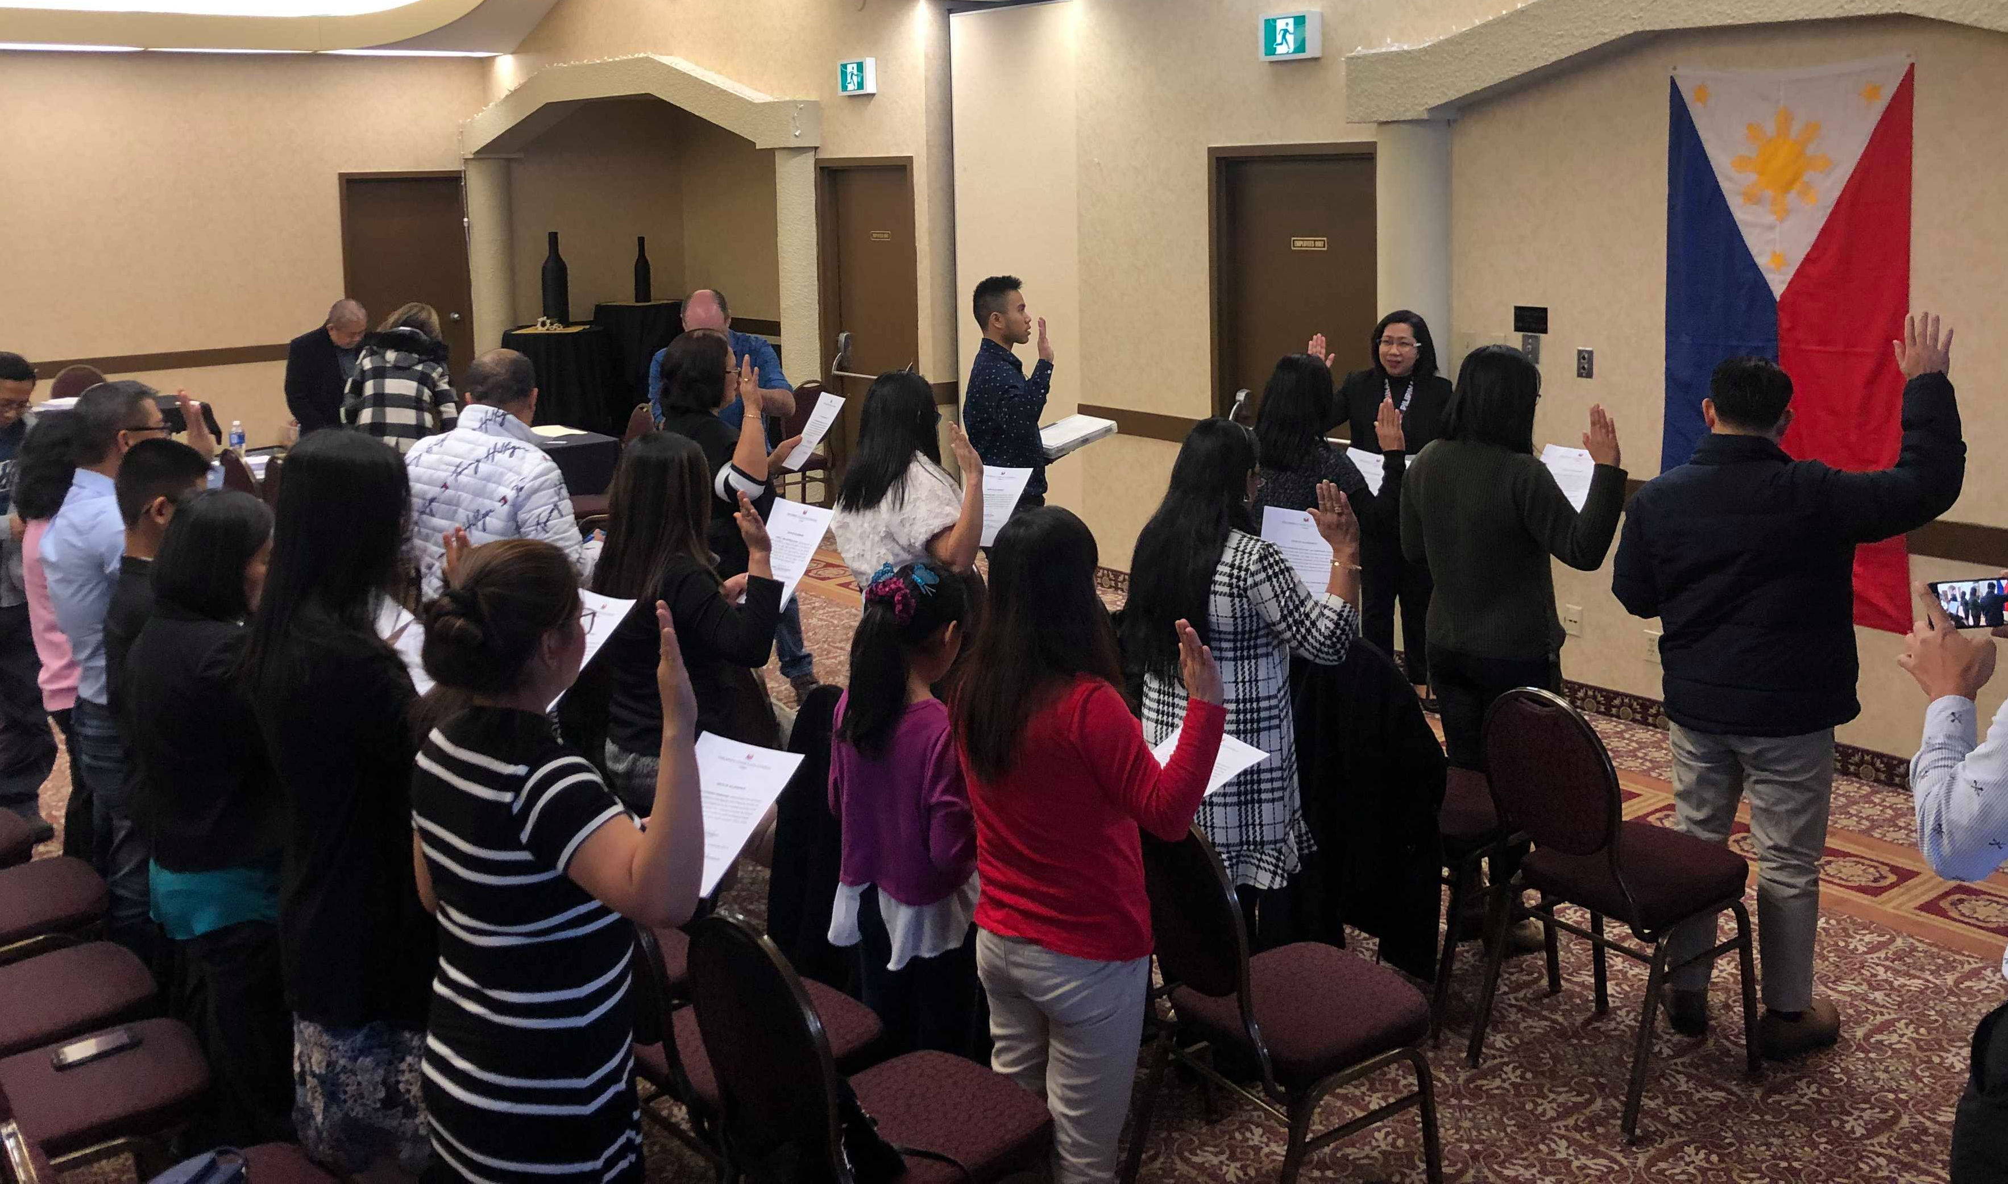

PHOTO: Consul Pamela Durian-Bailon, who headed the consular team in Grande Prairie on 8-10 November 2019, administers the Oath of Allegiance of the Filipino-Canadian citizens who reacquired or retained their Philippine citizenship at the consular outreach.

18 November 2019, Calgary – The Philippine Consulate General in Calgary conducted a consular outreach mission in Grande Prairie, Alberta, Canada on 8-10 November 2019. The six-member consular team, headed by Consul Pamela Durian-Bailon, delivered a total of 279 passport, notarial, NBI clearance renewal, civil registration, visa, and RA 9225 application services. The SSS Representative, Ms. Rhea Balicas-Biggs, provided services to 78 clients.

Consul Durian-Bailon also administered the Oath of Allegiance of fifteen (15) Filipino-Canadians who retained or reacquired their Philippine Citizenship after being naturalized as Canadians.

According to the 2016 Canada Census, there are about 3,105 Filipinos in Grande Prairie, which is approximately 715 kilometers away from Calgary. END

