Philippine Consulate General, Calgary
Suite 920, 517 10th Ave SW, Calgary AB, T2R 0A8 ▪ Tel: 403-455-9346; 403-455-9457 ▪
Website: philcongencalgary.org

PR- _54_ -2019

FILIPINO DESIGNERS SHINE AT THE 3rd CALGARY INTERNATIONAL FASHION AND ARTS WEEK

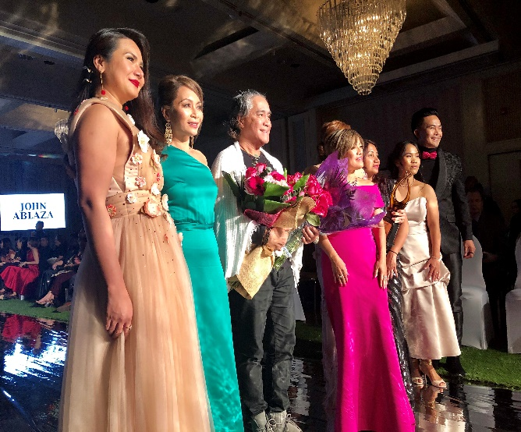
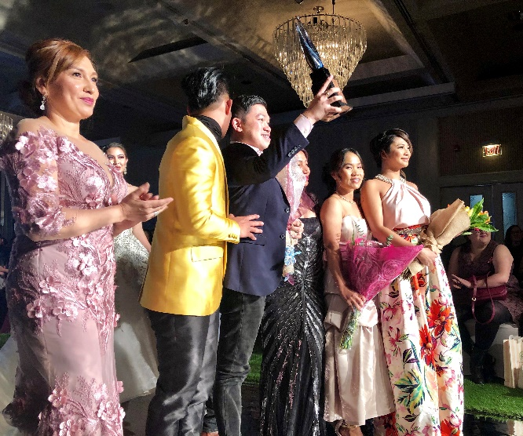

LEFT PHOTO: Filipino designer John Ablaza (center, holding bouquet), presents his collection at the LUSH Fashion Show on 29 September 2019 during the Third Annual Calgary International Fashion and Arts Week (CIFAW). RIGHT PHOTO: Filipino designer Kenny Ladaga (third from right) celebrates after his collection was showcased at the LUSH fashion show at CIFAW on 29 September 2019.

9 October 2019, Calgary – Filipino designers showcased their creativity and sartorial artistry in the exclusive fashion show L.U.S.H., which was held on 29 September 2019 at the Carriage House Inn in Calgary, Alberta, Canada as part of the third Calgary International Fashion and Arts Week (CIFAW).

The L.U.S.H show featured the collections of three Filipino designers, namely, Manila-based John Ablaza, Davao-based Kenny Ladaga, and Calgary-based Insig.Nia. The event marked the first time that CIFAW featured all-Filipino designers.

The fashion show was a production of Spotlight Couronne Internationale Inc. (SCII), which was also founded by Filipino fashion industry figure Limuel Hayag Vilela. According to SCII, the setup of the “LUSH" (Lifestyle, Unconventional, Selfless and High-Fashion) was inspired by love and freshness in a forest garden.

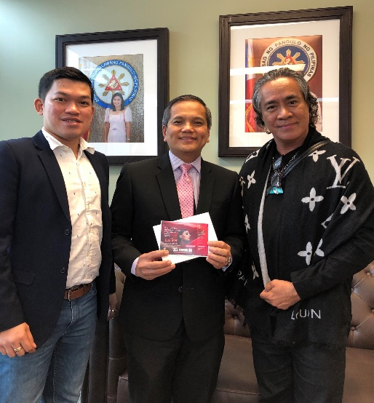
Celebrating diversity, L.U.S.H featured models of diverse backgrounds, which included Filipina talents.

Before the L.U.S.H. event, Messrs. Ablaza and Ladaga, Spotlight Couronne’s Messrs. Limuel Hayag Vilela and Alvin Francia, and Ms. Pierre-Lyn Arcega paid a courtesy call on Consul General Zaldy Patron at the Philippine Consulate General on 25 September. The Consul General expressed appreciation to the two fashion creatives and the organizers for showcasing Filipino creations at the fashion event.

Consul General Patron also attended the L.U.S.H. to show his support for the designers and organizers. END
PHOTO: Filipino designers John Ablaza and Kenny Ladaga call on Consul General Zaldy Patron on 25 September 2019.

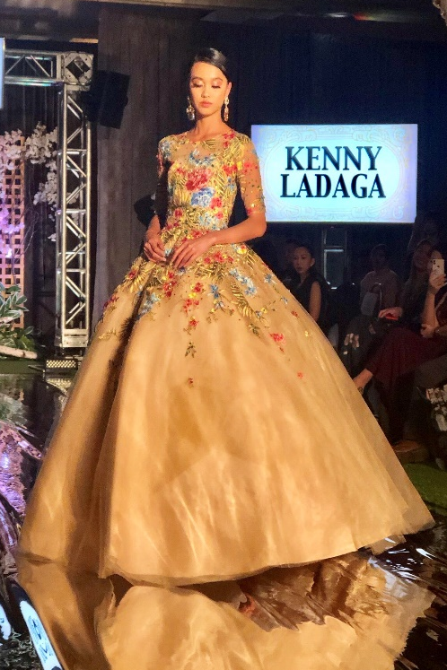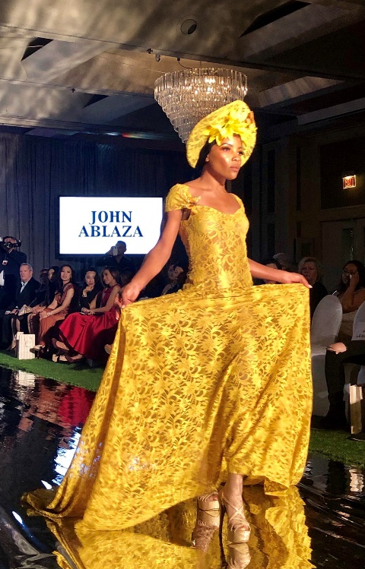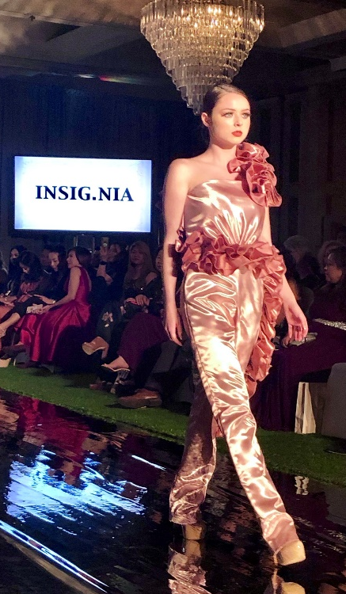
PHOTOS, LEFT TO RIGHT: CIFAW models walk down the runway wearing the designs of Kenny Ladaga, John Ablaza and Insig.Nia, 29 September 2019.

