Philippine Consulate General, Calgary
Suite 920, 517 10th Ave SW, Calgary AB, T2R 0A8 ▪ Tel: 403-455-9346; 403-455-9457 ▪
Website: philcongencalgary.org

PR- 41 -2019

MORE THAN A THOUSAND FILIPINOS AVAIL THEMSELVES OF CONSULAR SERVICES AT THE PHILIPPINE CONSULATE GENERAL IN CALGARY’S CONSULAR OUTREACH IN EDMONTON

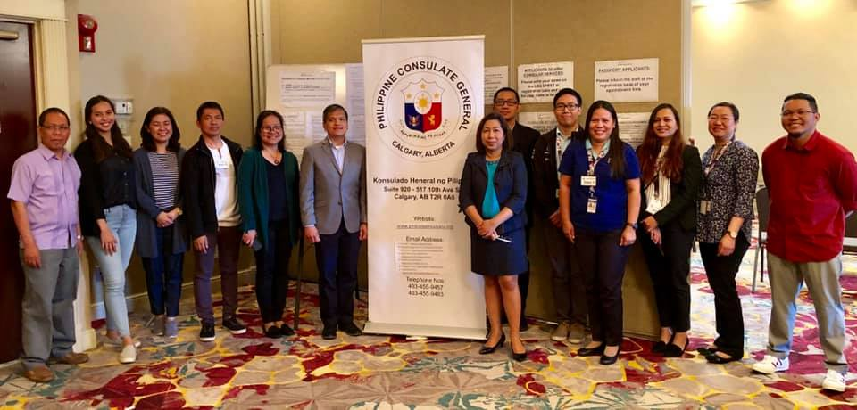
Consul General Zaldy Patron (6th from left) and members of the consular outreach team, including
OWWA Welfare Officer Ms. Lilia De Guzman (5th from left) and SSS Representative Ms. Rhea Balicas
(4th from right) and their staff, at end of the consular outreach in Edmonton.

28 August 2019, Calgary – The Philippine Consulate General (PCG) in Calgary, led by Consul General Zaldy Patron, conducted its second consular outreach mission in Edmonton on 24-26 August 2019.

The PCG provided a total of 907 consular services including passport renewal, notarization, NBI Form verification, civil registration (Reports of Birth, Marriage, Death), and citizenship reacquisition/retention. A total of 59 applicants for Philippine citizenship reacquisition/retention took their oath of allegiance at the outreach.

In addition to consular services, 122 clients availed themselves of assistance and services from Vancouver-based Philippine Overseas Labor Office (POLO) and Overseas Workers Welfare Administration (OWWA), represented in the outreach by Welfare Officer Ms. Lilia De Guzman, and from the Social Security System (SSS) led by SSS Representative Ms. Rhea Balicas.

Three Filipino-Canadian lawyers, Atty. Joseph and Katrina Angeles and Atty. Peter Recto, offered free legal advice to 29 consular outreach clients who asked questions relating to immigration, taxation, property and family laws and other concerns.

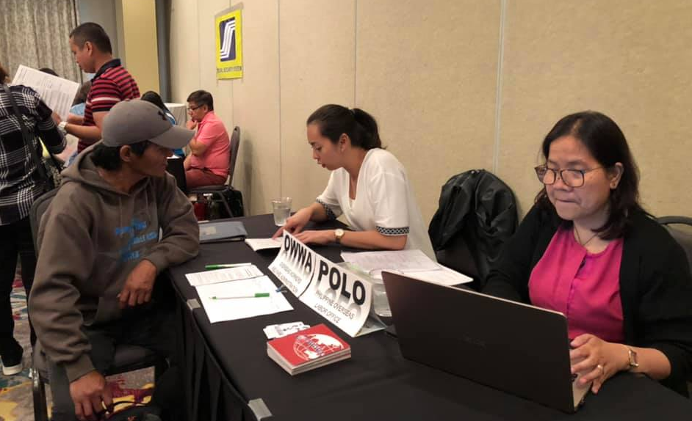  OWWA-POLO team led by Welfare Officer Ms. Lilia De Guzman assisting a client. | 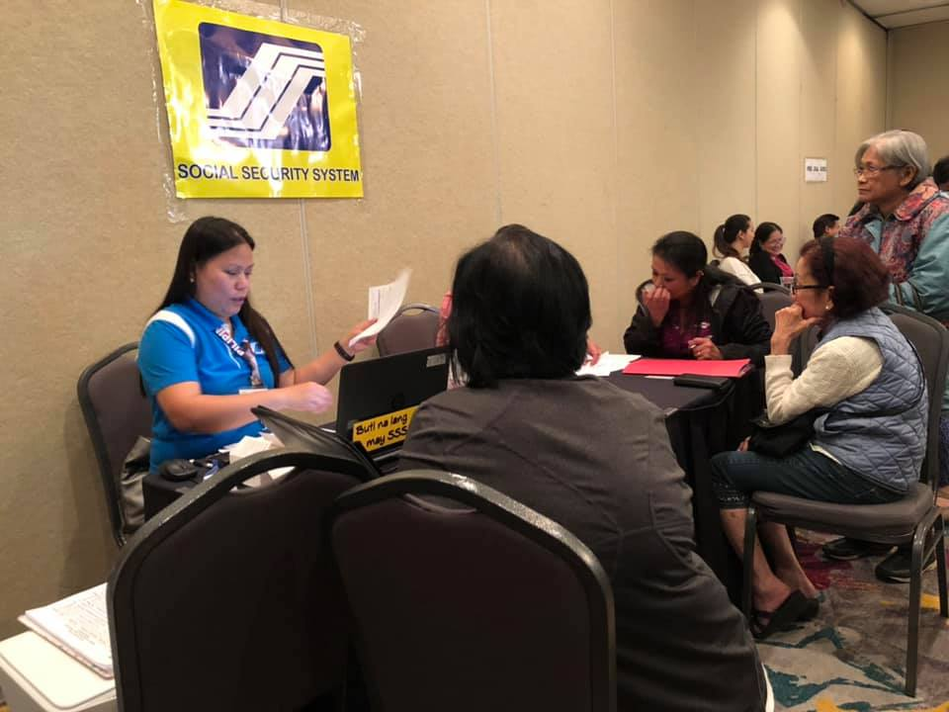  SSS Representative Ms. Rhea Balicas answers queries of SSS pensioners and members.
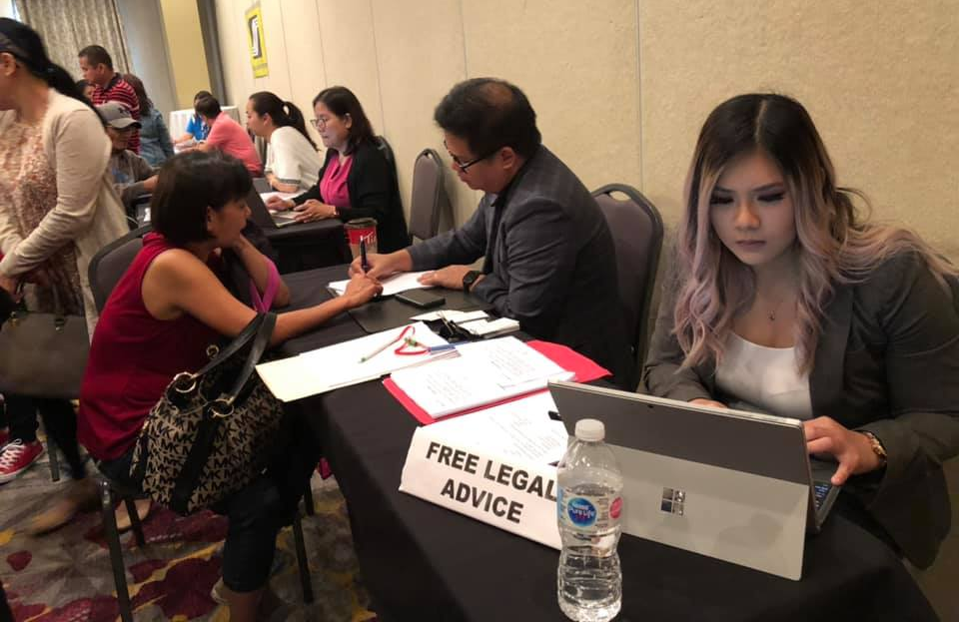

Free legal advice given to clients waiting for consular services.

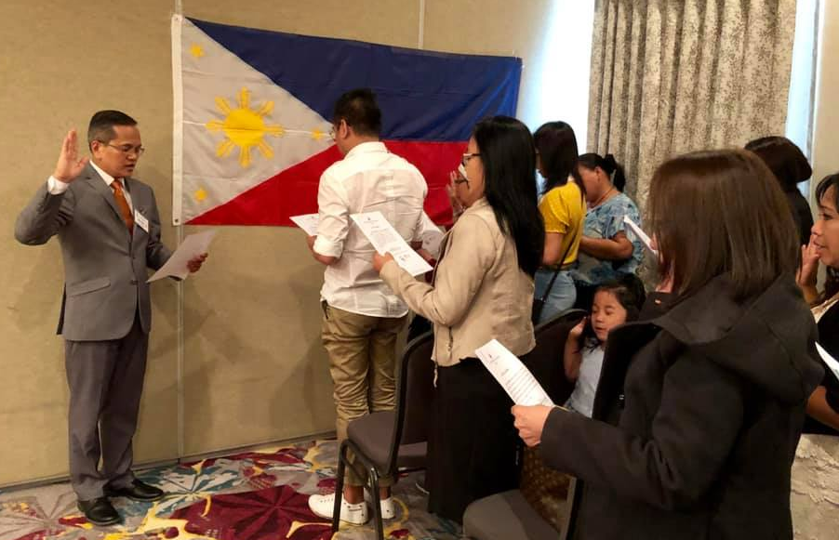
Consul General Zaldy Patron administers the oath of allegiance to
applicants for PH citizenship reacquisition/retention

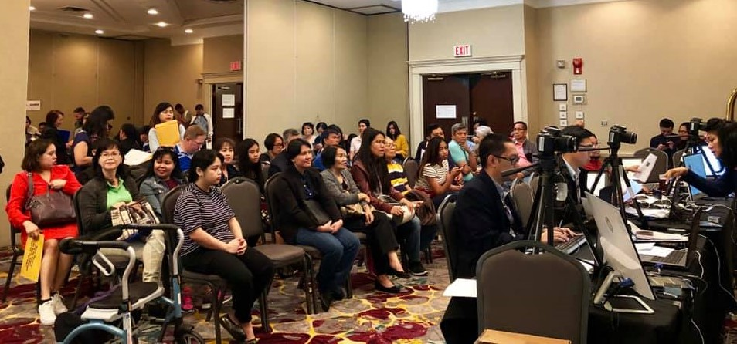
Applicants waiting for their turn for passport biometrics.

Alberta is host to about 175,000 Filipinos based on the 2016 Canada Census. About 64,000 of them are based in Edmonton. END

