PRESS RELEASE
Philippine Consulate General, Calgary
Suite 920, 517 10th Ave SW, Calgary AB, T2R 0A8 ▪ Tel: 403-455-9346; 403-455-9457 ▪
Website: philcongencalgary.org

PR- 5 -2019

PCG CALGARY PARTNERS WITH CIWA
IN GIVING “POST-ARRIVAL ORIENTATION’
TO REUNITED FILIPINO FAMILIES
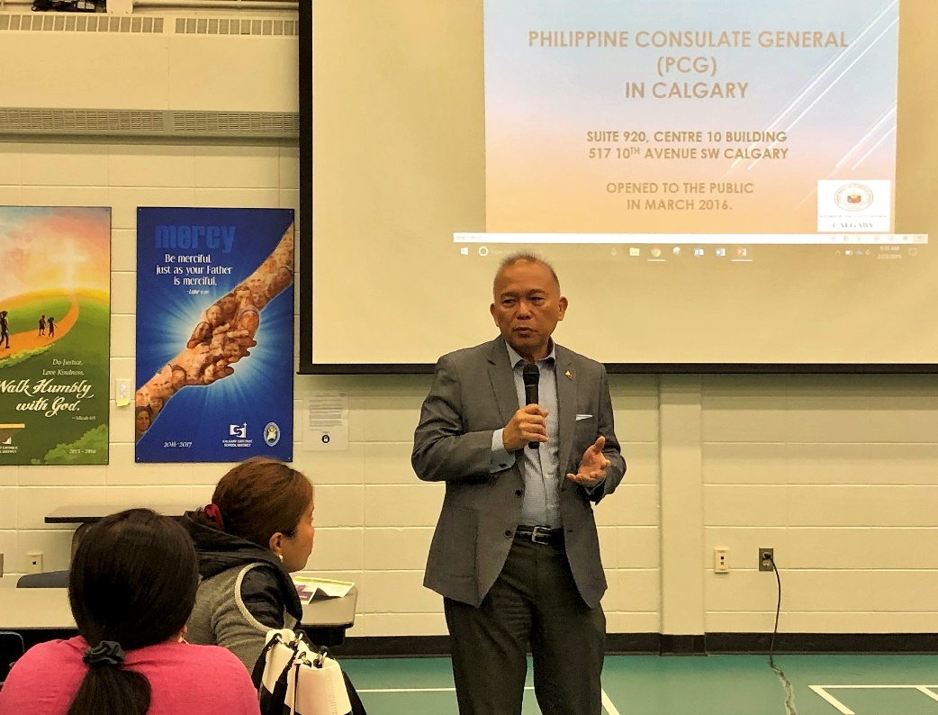
Consul General Gilberto Asuque welcoming the newly-arrived Filipinos during the Family Reunification Workshop held by CIWA on 23 February 2019.

25 February 2019, Calgary – The Philippine Consulate General (PCG) in Calgary recently partnered with the Calgary Immigrant Women’s Association (CIWA) in providing “post-arrival orientation” to reunited Filipino families in Calgary.

CIWA organized a Family Reunification Workshop in Calgary on 23 February 2019 where Consul General Gilberto Asuque and Deputy Consul General DCG Zaldy Patron spoke about the programs and services of the PCG for the Filipino community.

CIWA is a non-profit organization established in 1982 as a registered charity. It offers 40 programs and projects in the areas of settlement and integration, literacy and language training, employment support and bridging programs, laws against family violence, parenting, individual counselling, in-home support, civic engagement, health, housing and community development.
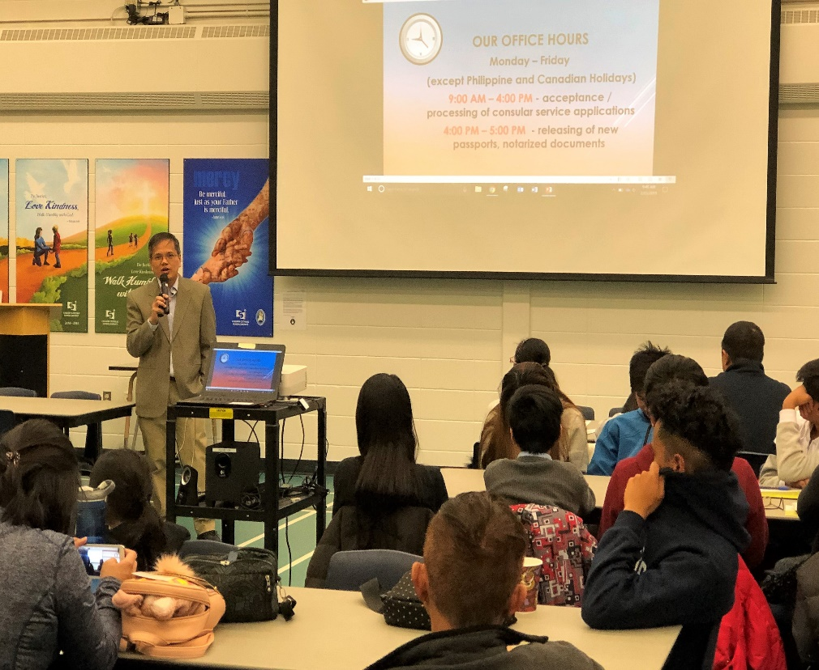

Deputy Consul General Zaldy Patron explaining the consular services of the PCG to the workshop participants.

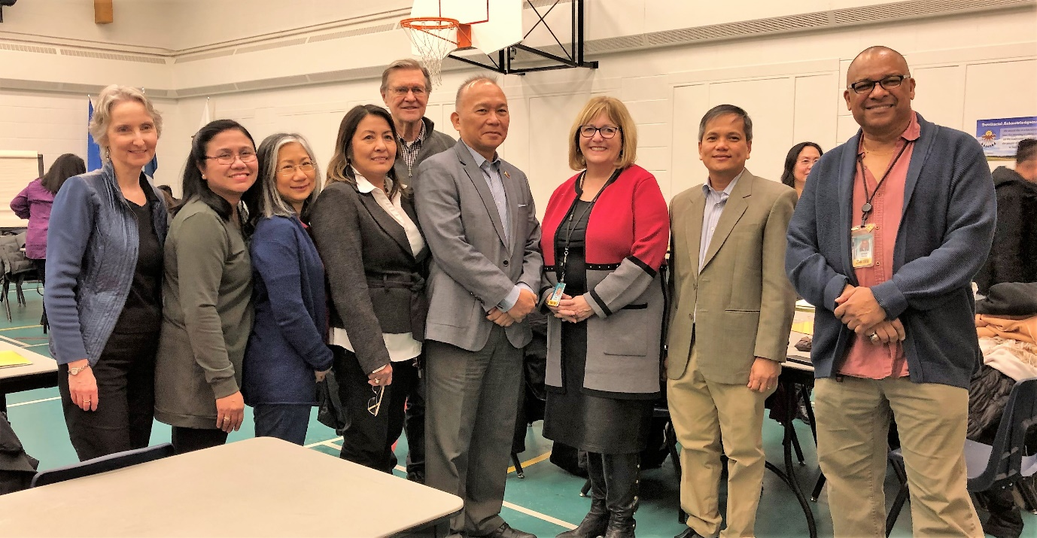
One of CIWA’s programs is the Filipino Community Development Program that conducts regular Family Reunification Workshop. The workshop is designed to assist newly reunited Filipino families in Calgary on how to quickly integrate into the Canadian society.
Consul General Gilberto Asuque (4th from right) and Deputy Consul General Zaldy Patron (2nd from right) with some of the coordinators and speakers at the CIWA’s Family Reunification Program held in Calgary on 23 February 2019.

About 60 Filipinos from 18 families attended the recent workshop. Breakout

Break-out sessions were held for parents, youth and children to discuss such topics as parenting law in Canada, power of education and success in schools, child safety tips, making healthy snack, and childcare.

Filipinos interested to know more about CIWA’s programs may visit its website https://www.ciwa-online.com/. The PCG website, www.philcongencalgary.org, provides information about the PCG’s consular services. END.

