Philippine Consulate General, Calgary
Suite 920, 517 10th Ave SW, Calgary AB, T2R 0A8 ▪ Tel: 403-455-9346; 403-455-9457 ▪
Website: philcongencalgary.org

PR- 29 -2019

PCG CALGARY SUPPORTS
PHILIPPINE CUISINE FESTIVAL GALA

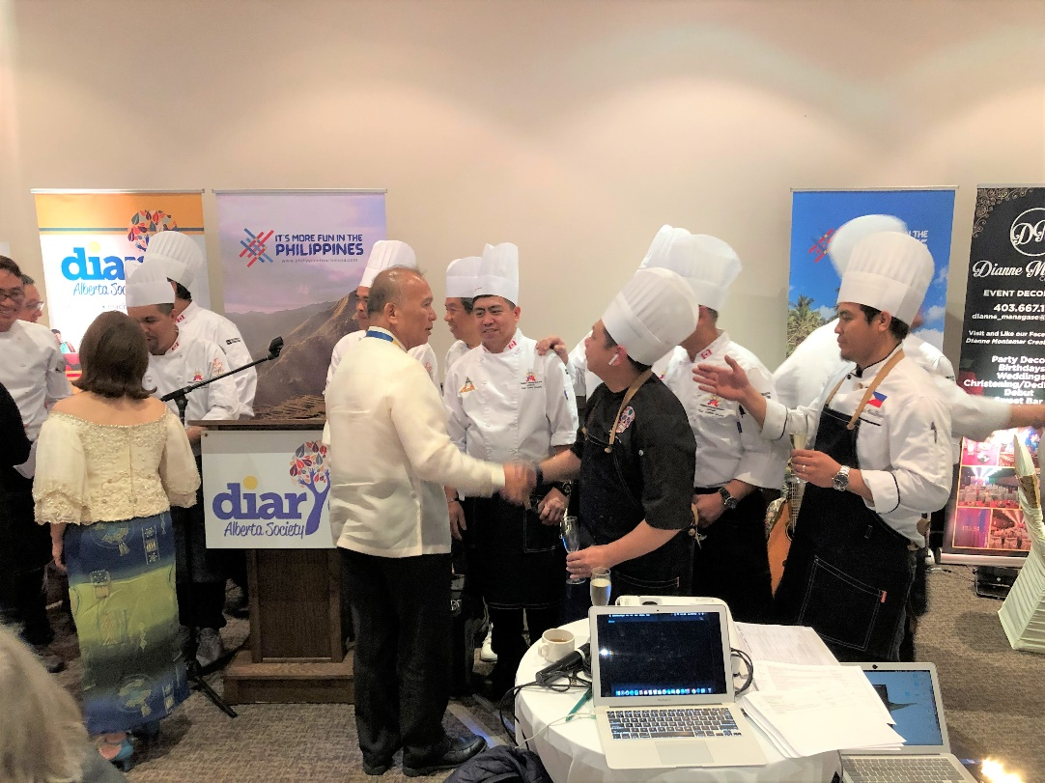
Consul General Gilberto Asuque congratulates the Filipino chefs who took part in the Philippine Cuisine Festival Gala in Calgary on 17 June 2019.

25 June 2019, Calgary – The Philippine Consulate General supported the Philippine Cuisine Festival Gala held on 17 June 2019 at the Winston Golf Club in Calgary.

Consul General Gilberto Asuque congratulated the event’s main organizers - Diaryo Alberta Society (DAS) and the Philippine & Culinary Federation of Canada (PCFC) – for putting up the event as part of the month-long celebration of the Philippine Heritage Month in Alberta, Canada.

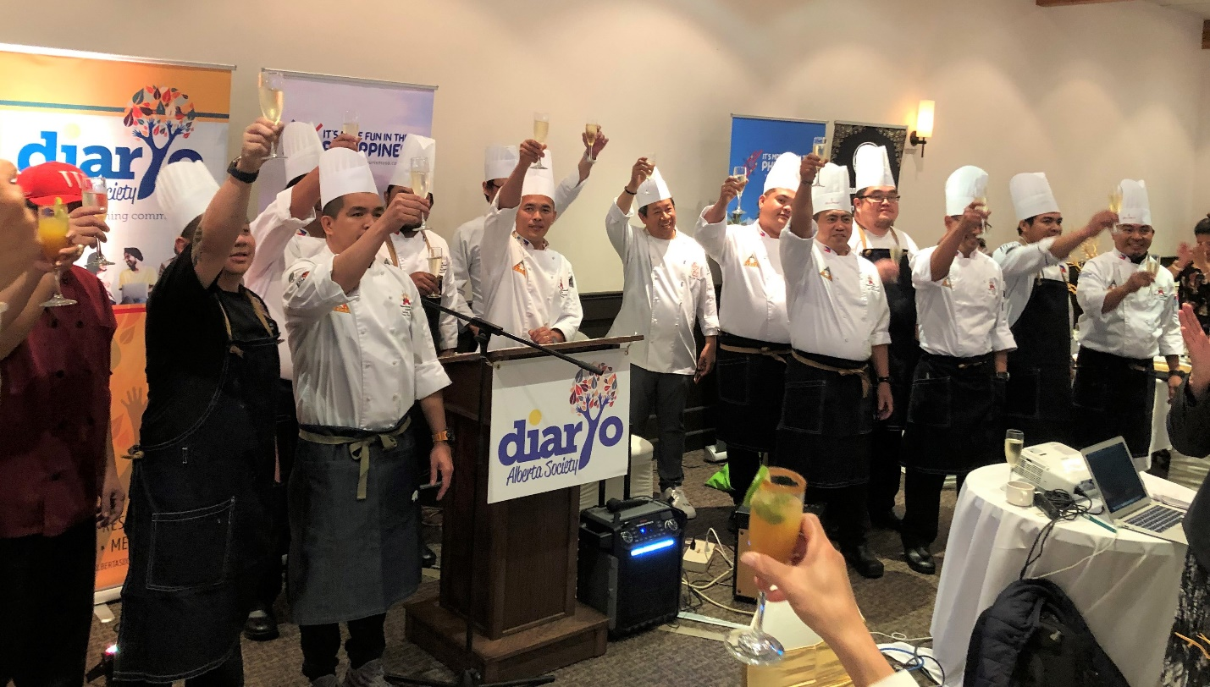
Members of the Philippine & Culinary Federation of Canada at the end of the gala event.

Eighteen (18) Filipino chefs belonging to the PCFC came up with Filipino dishes that were served to about 170 guests in fine-dining style. The Filipino chefs came from various parts of the province of Alberta – Banff, Canmore, Cochrane, Calgary, Strathmore – and from Saskatoon, Saskatchewan and Quezon City, Philippines.

The Filipino dishes showcased were the following:

Sutukil – A trio seafood dish with yellow fin tuna as the main ingredient and done in sugba (grilled), tula (boiled) and kilaw (marinated in vinegar). This dish is popular in General Santos.

Chicken Inasal with Cucumber Salad – Grilled chicken cooked with calamansi, lemongrass and anatto oil. The dish comes from Bacolod.

La Paz Batchoy – A sweet and salty beef noodle soup popular in La Paz, Iloilo.

Hamonado and Biringhe Bulakenyo – Hamonado is pork meat marinated overnight with sweetened pineapple sauce. Baringhe, popular in Bulacan, is rice cooked with coconut milk and turmeric oil.

Durian Cheesecake – A dessert made of durian, an exquisite tasting fruit that is abundant in Davao.

Mango Calamansi Cocktail – Cocktail drink combining the Philippine mango and Philippine lime.

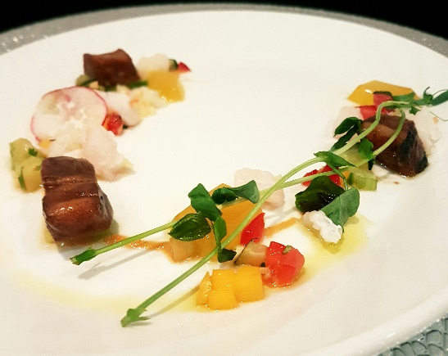
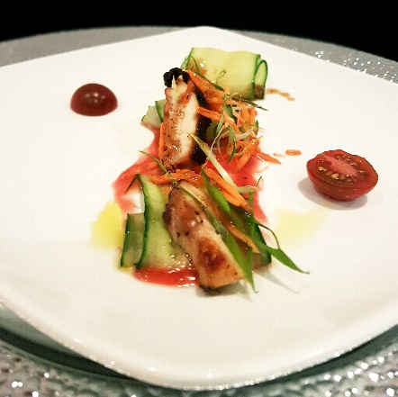
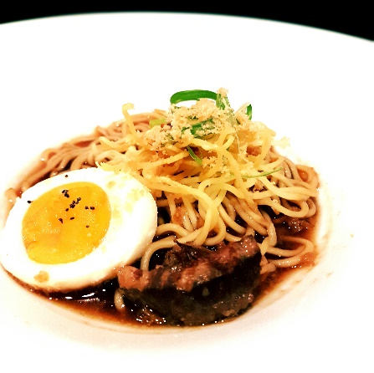
Sutukil, Chicken Inasal with Cucumber Salad and La Paz Batchoy (Photo credit: DAS)

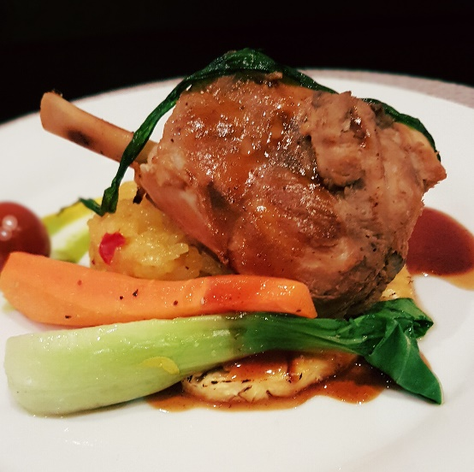
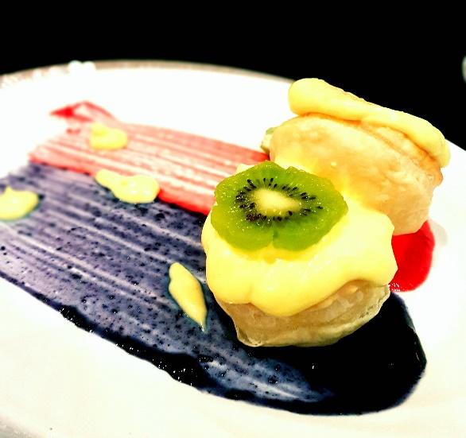
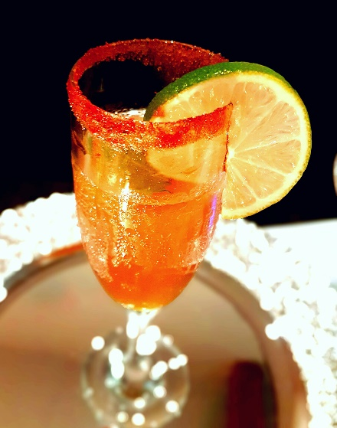
Hamonado and Biringhe Bulakenyo, Durian Cheesecake and Mango Calamansi Cocktail (Photo credit: DAS)

The Philippine Department of Tourism-San Francisco was also among the event’s sponsors.

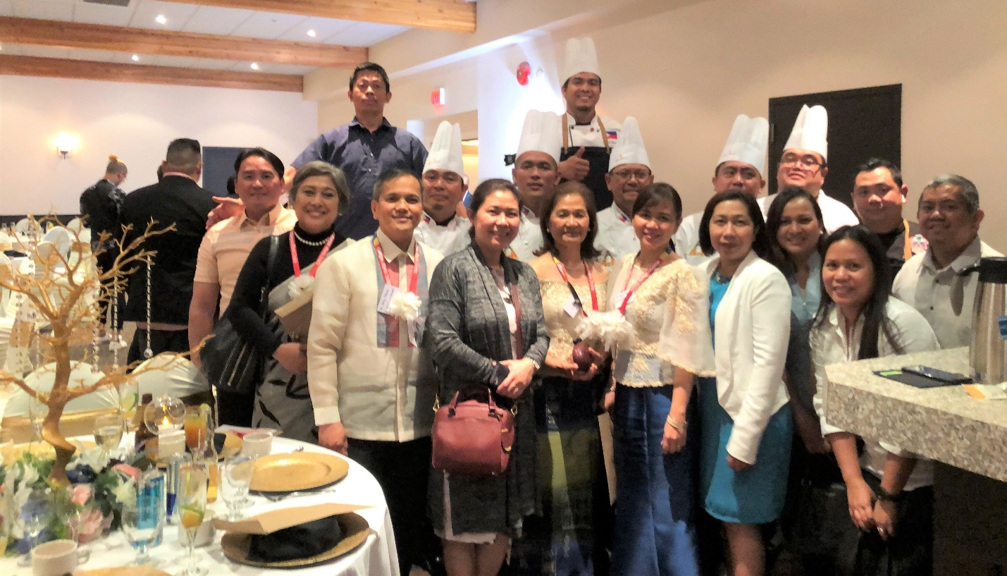
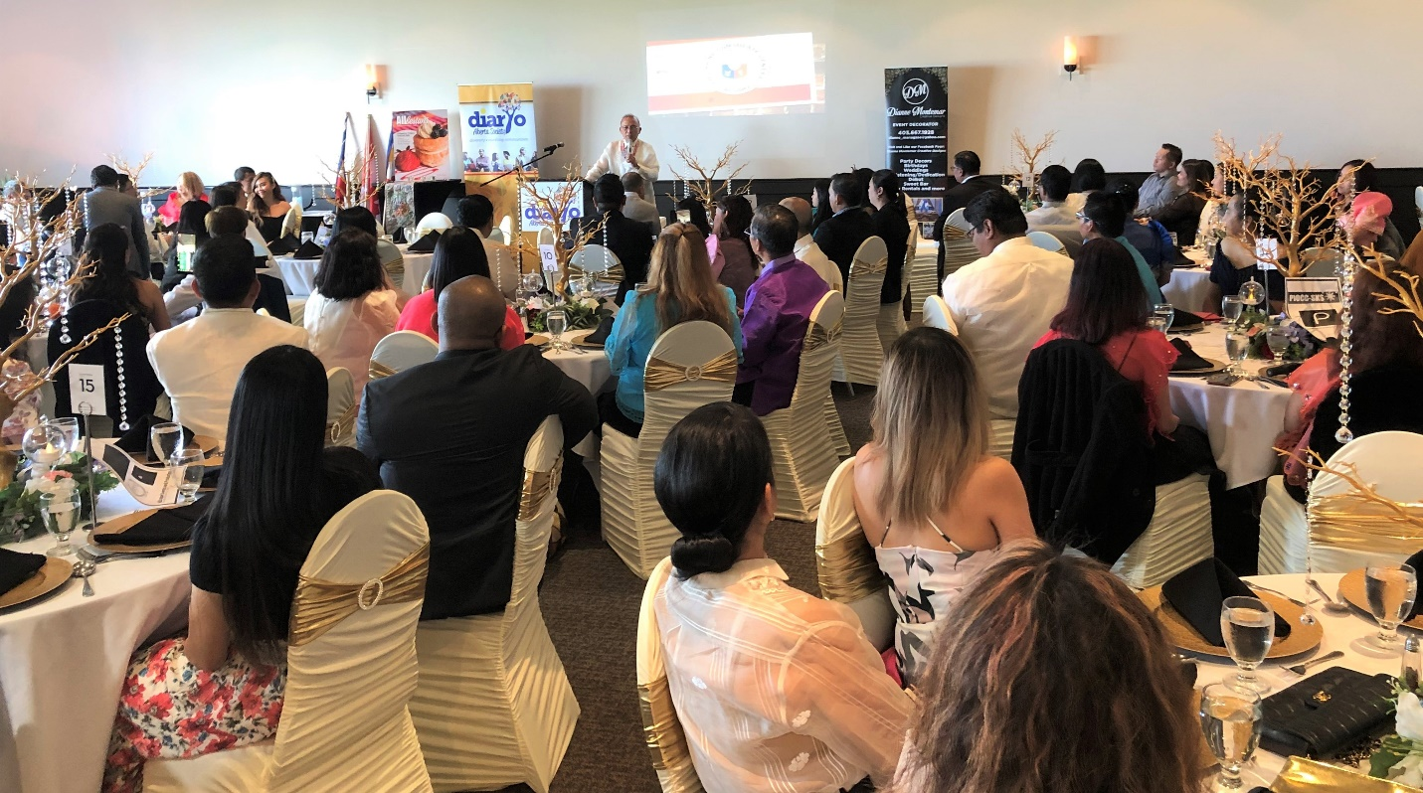
Consul General Gilberto Asuque addressing the guests at the Philippine Cuisine Festival Gala in Calgary.
Madame Rosalie Asuque and the officers and staff of the Philippine Consulate General in Calgary together with some of the participating Filipino chefs.

