Philippine Consulate General in Calgary
PR- 15 - 2019 11 May 2019

CONSUL GENERAL ENCOURAGES PROFESSIONAL FILIPINO-CANADIANS TO SHARE EXPERIENCES AND CAREER GROWTH IN CANADA WITH THE COMMUNITY

11 May 2019, Calgary – Consul General Gilberto Asuque congratulated five successful Filipino-Canadians and encouraged more sharing of the experience and career growth of Filipino migrants in Canada with the Filipino community.

Consul General Asuque spoke at the 8th edition of the Filipino Champions Talk (FCT) 2019 featuring five outstanding professionals from top universities in the Philippines. The FCT is a project of The Filipino Champions of Canada (TFCC), headed by Mr. Jerry Caingcoy, Founder/President, that provides a forum of Filipino migrants to share their experiences, life challenges, and success in their careers to serve as examples and encouragement for other Filipino migrants in their own quest for family and career fulfilment.

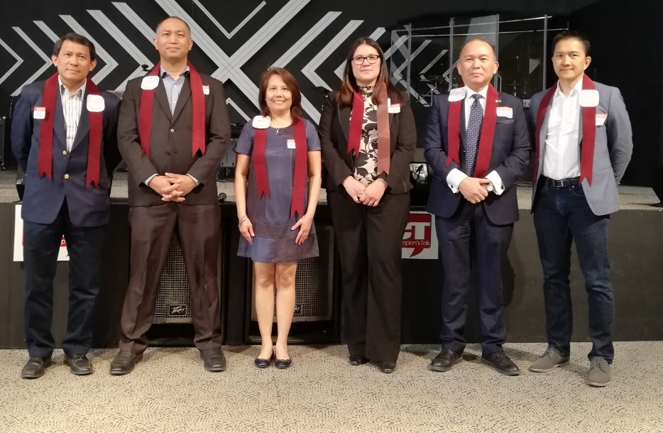
The 8th FCT was held at the Champion Life Center, South East Calgary, and heard the experiences and success stories of Atty. Beverly Pangcog-Mendoza, graduate of Ateneo De Manila and now an associate in the Wills, Trusts & Estates group at McLeod Law in Canada; Dr. Rachelle De Gracia, graduate of De La Salle University and now a practicing family physician with clinic in Calgary; Eng. Brian Mercader, Metallurgical/ Environmental Engineer, graduate of the University of the Philippines, with expertise in Water, Wastewater, Environmental Management, Research and Development, International Development, Quality and Environmental Management Systems at the same time a university professor; Eng. Renato Echavez, Electronics Communications Engineer, graduate of the Don Bosco Institute of Technology and now is a financial adviser in a major finance company; and Eng. Eugene Sicat, Computer Engineer, graduate of Mapua Institute of Technology and now a project manager in one of Canada’s top energy company.
ConGen Asuque (5th from left) with Eng. Echavez, Eng. Mercader, Dr. de Gracia, Atty. Mendoza and Eng. Sicat (L-R) at the 8th FCT.
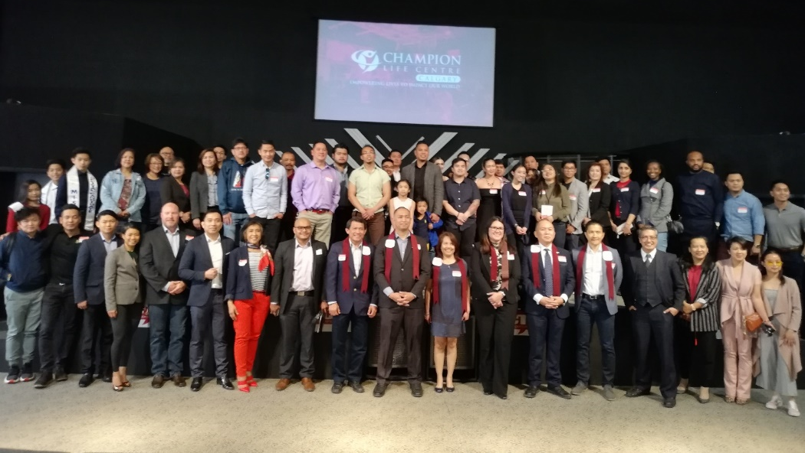
Consul General Asuque thanked the TFCC for providing a forum and network for successful Filipino migrants in Canada to share their experiences and struggles in their professional growth as examples for other Filipinos to achieve their ambitions for their families and careers. END
ConGen Asuque and Mr. Caingcoy, TFCC Founder/President, with the speakers and participants of the 8th FCT

