Philippine Consulate General, Calgary
Suite 920, 517 10th Ave SW, Calgary AB, T2R 0A8 ▪ Tel: 403-455-9346; 403-455-9457 ▪
Website: philcongencalgary.org

PR- 38 -2019

CONSUL GENERAL PATRON JOINS
TAGUIG FIESTA CELEBRATION IN EDMONTON

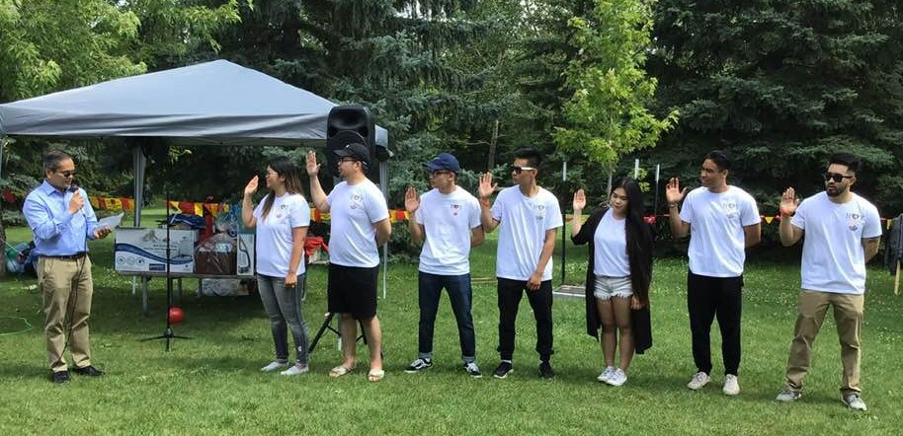
Consul General Zaldy Patron administers the oath of office of the first-ever set of officers of the Heart of YEG (HOY) Filipino Community in Edmonton.

2 August 2019, Calgary – Consul General Zaldy Patron joined the Filipino-Canadian members of the Taguig community in Edmonton, Alberta, Canada in their celebration of the Feast of Day of St. Anne and the Fiesta of Taguig on 28 July 2019.

The Taguig Community of Edmonton, headed by Mr. Oscar Dela Paz, and the Heart of YEG (HOY) Filipino Community, led by Ms. April Dela Paz – Dela Cruz, were the event’s main organizers.

The Taguig Community of Edmonton has been existing for 14 years now and started organizing the annual fiesta celebration over the last 13 years. The organization has undertaken several projects, including medical and dental mission, feeding program, school supplies distribution and relief goods donation, that benefitted the people of Taguig City, Metro Manila in the Philippines. HOY, on the other hand, is newly-formed organization composed of second-generation Filipinos who would like to support the Filipino-Canadian community in Edmonton.

One of the highlights of the event was Consul General Patron’s administration of the oath of office of HOY’s first set of officers.

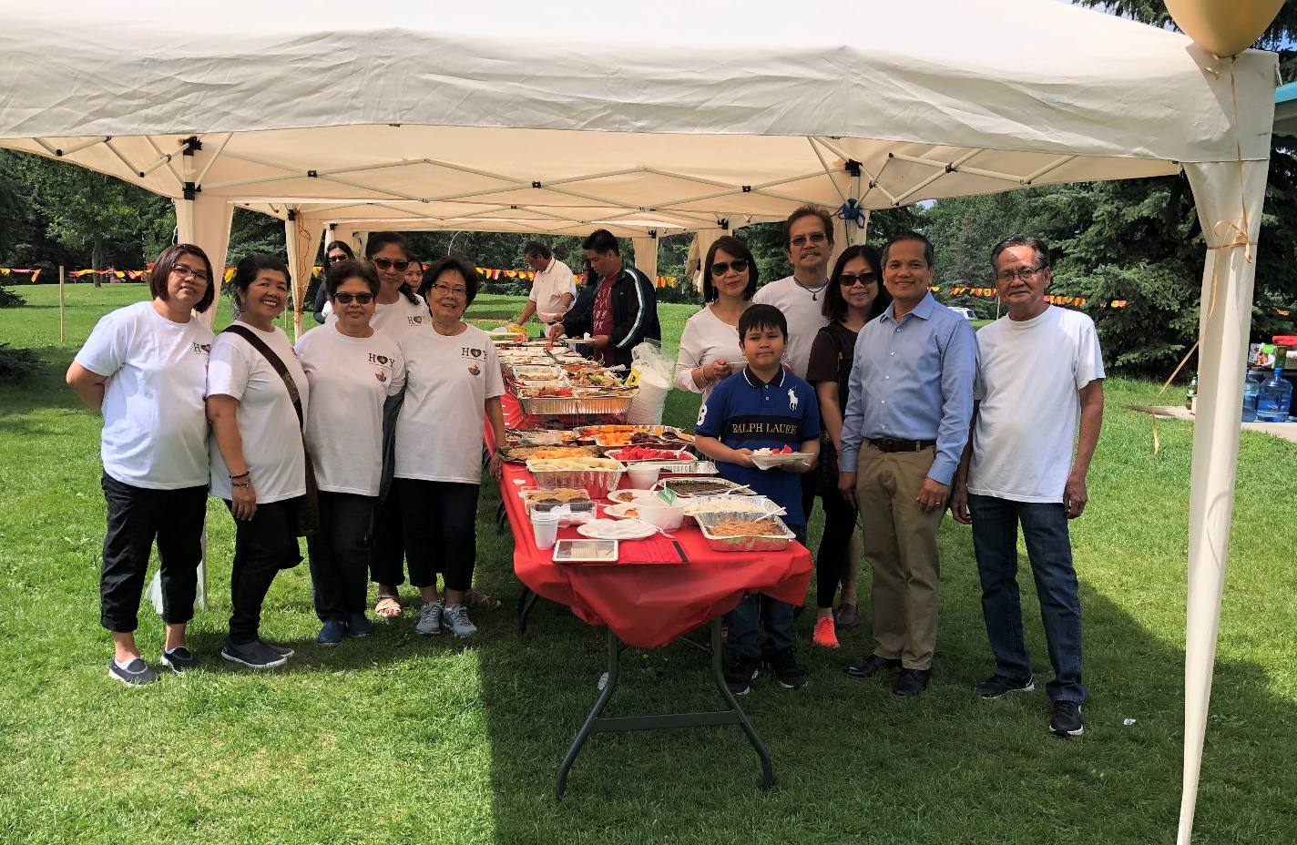
Consul General Zaldy Patron together with some of the members of the Taguig Community of Edmonton.

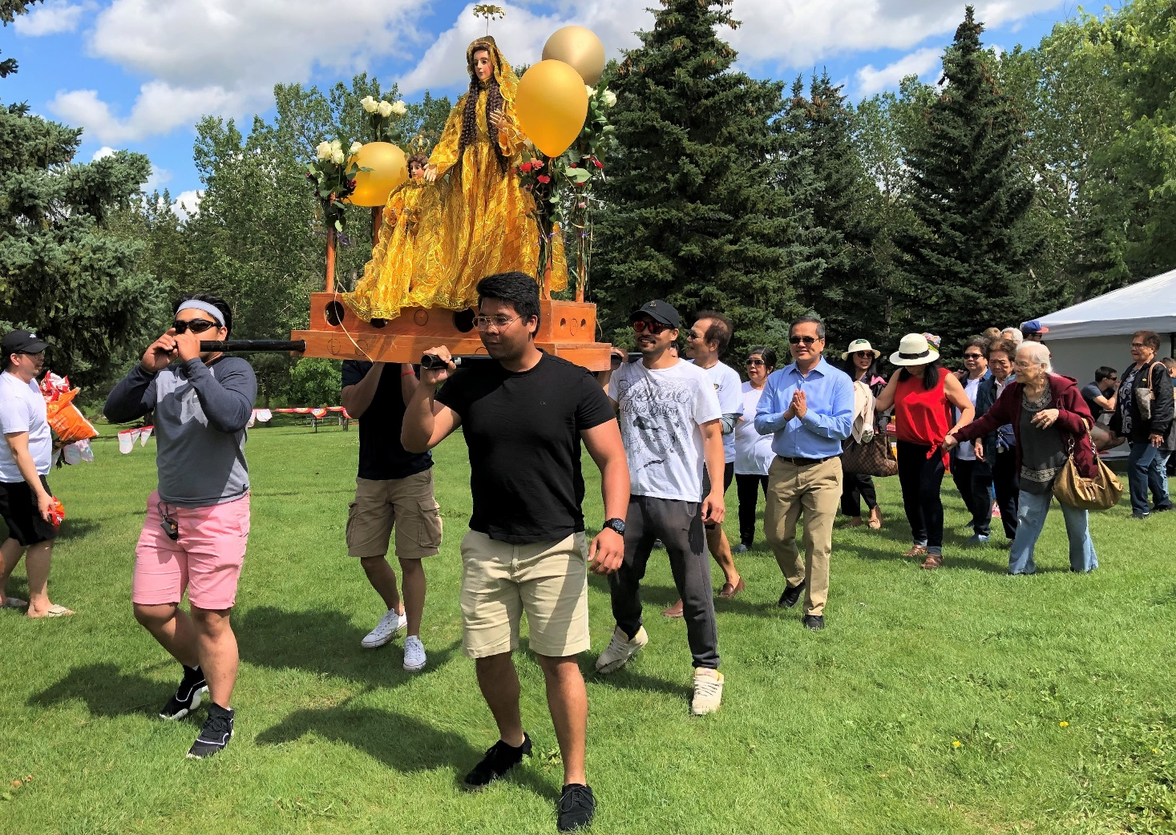
Consul General Zaldy Patron joins the procession for St. Anne of Taguig.

Consul General Patron thanked the Taguig community in Edmonton for the assistance they have extended to their native city over the years and commended the second generation Filipino-Canadians for their greater involvement in the Filipino community. END.

