Philippine Consulate General, Calgary
Suite 920, 517 10th Ave SW, Calgary AB, T2R 0A8 ▪ Tel: 403-455-9346; 403-455-9457 ▪
Website: philcongencalgary.org

PR- 11 -2019

PCG CALGARY CONDUCTS SUCCESSFUL
FINAL TESTING AND SEALING (FTS)
OF THE VOTE COUNTING MACHINE (VCM)

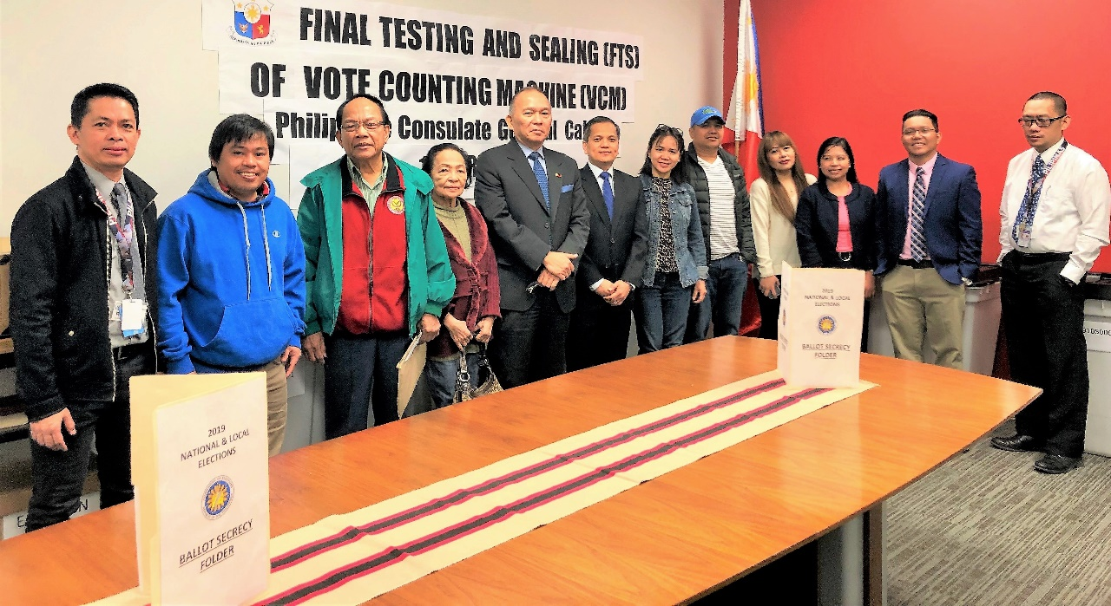
Consul General Gilberto Asuque, (5th from left) and SBEI Chairperson and Deputy Consul General Zaldy Patron (6th from left) together with the test voters and members of the Special Board of Election Inspectors (SBEI) and Special Ballot and Reception Custody Group (SBRCG) during the conduct of the Final Testing and Sealing (FTS) of Vote Counting Machine (VCM) for the 2019 Philippine National and Local Elections. The FTS was held on 10 April 2019 at the Philippine Consulate General office in Calgary.

10 April 2019, Calgary – The Philippine Consulate General (PCG) in Calgary successfully conducted today the Final Testing and Sealing (FTS) of Vote Counting Machine (VCM). The VCM will be used in counting the votes of the registered voters in Calgary for the 2019 Philippine National and Local Elections. Overseas registered voters can vote for Senators and Party List Representative.

The FTS, which was conducted in the presence of test voters, showed that the VCM to be used by the Special Board of Election Inspectors (SBEI) for the postal voting in Calgary was in good condition. SBEI Chairperson Zaldy Patron led the conduct of the FTS.

The overseas voting period will start on 13 April 2019 and end on 13 May 2019 at 6:00 PM (Philippine Time). The PCG will mail the packets containing the ballots to registered voters who are expected to accomplish the ballots and mail them back to the PCG. The registered voters are expected to buy the postage stamps they will use in mailing their accomplished ballots.

On 13 May 2019 at 4:00 AM, simultaneous with the counting of votes in the Philippines, the SBEI in Calgary will begin counting the ballots it will receive during the 30-day voting period. The counting of votes will be held at the PCG office. END.

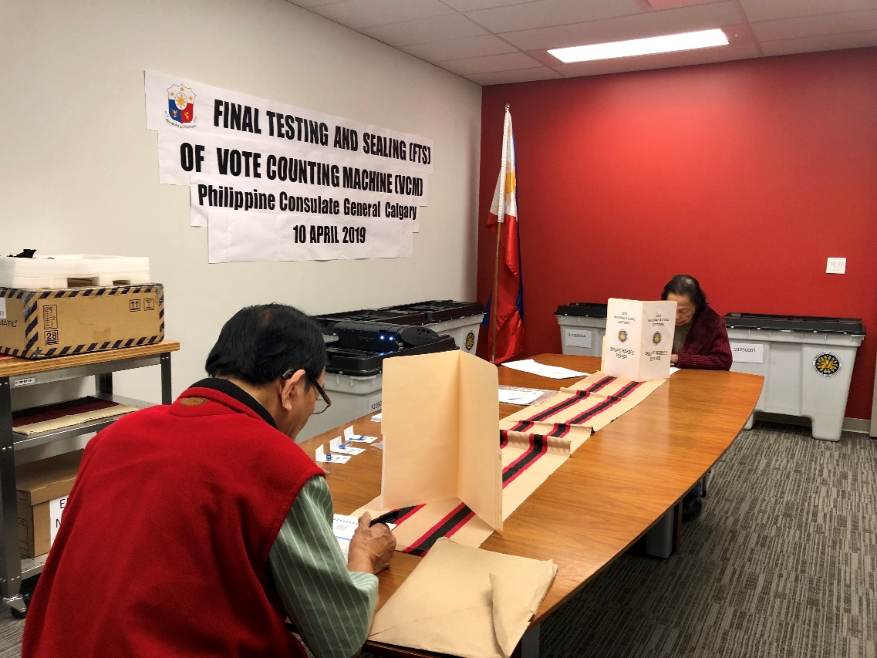
Test voters accomplishing the ballots to be used for the FTS.

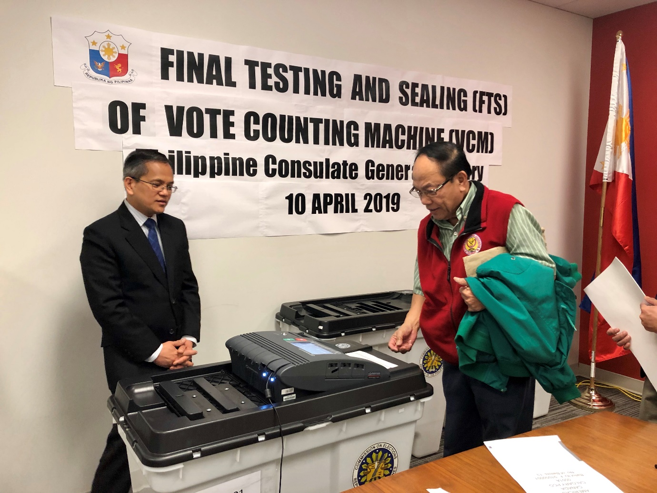
A test voter feeding his accomplished ballot to the VCM during the FTS in the presence of SBEI Chairperson Zaldy Patron.

