Philippine Consulate General, Calgary
Suite 920, 517 10th Ave SW, Calgary AB, T2R 0A8 ▪ Tel: 403-455-9346; 403-455-9457 ▪
Website: philcongencalgary.org

PR- 35 -2019

FREE FILIPINO BREAKFAST SERVED
AT THE 2019 CALGARY STAMPEDE FESTIVAL
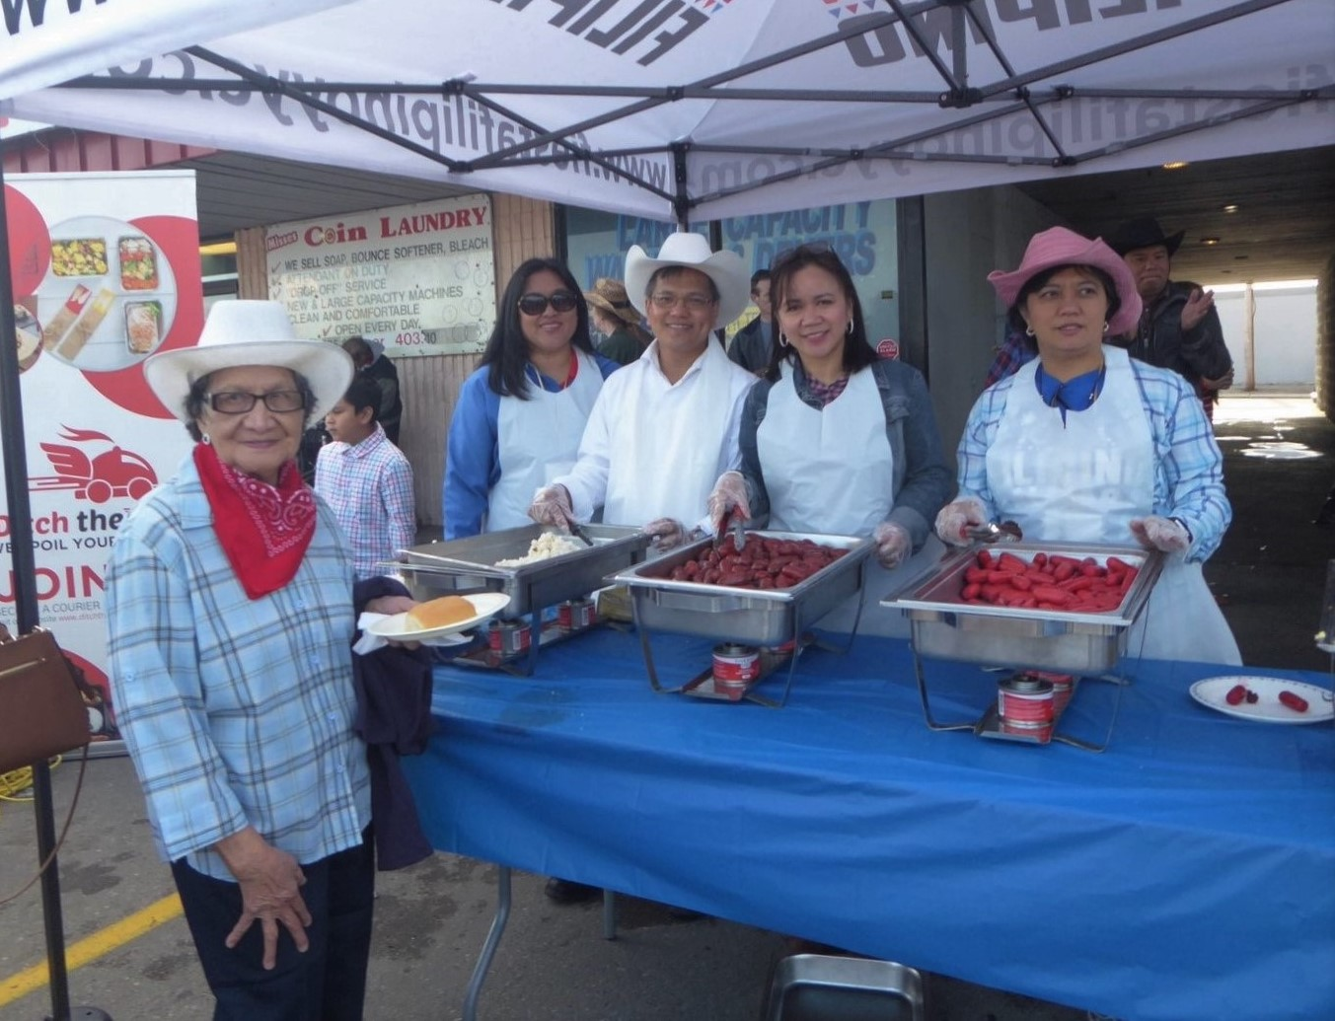
Consul General & Mrs. Zaldy Patron (3rd and 2nd from right) joined the members of the Philippine Festival Council of Alberta in serving free Filipino breakfast at the Agahan Filipino Stampede Breakfast on 7 July 2019 in Calgary, Alberta, Canada.

15 July 2019, Calgary - The just concluded world-famous Calgary Stampede, which ran from 5 to 14 July 2019, saw free Filipino-style breakfast of fried rice, pandesal, longganisa, hotdog and scrambled eggs served to about 3,500 people during the 4th Agahan Filipino Stampede Breakfast on 7 July 2018.

The Sunday morning event, held at the parking lot of Filipino-owned Pacific Hut Restaurant in Southeast Calgary, also featured live singing and dance performances of local Filipino talents in Calgary.

The event’s main organizer was the Philippine Festival Council of Alberta (PFCA) with Pacific Hut Restaurant, Hong Kong Supermarket and Tim Hortons as among the major corporate sponsors.

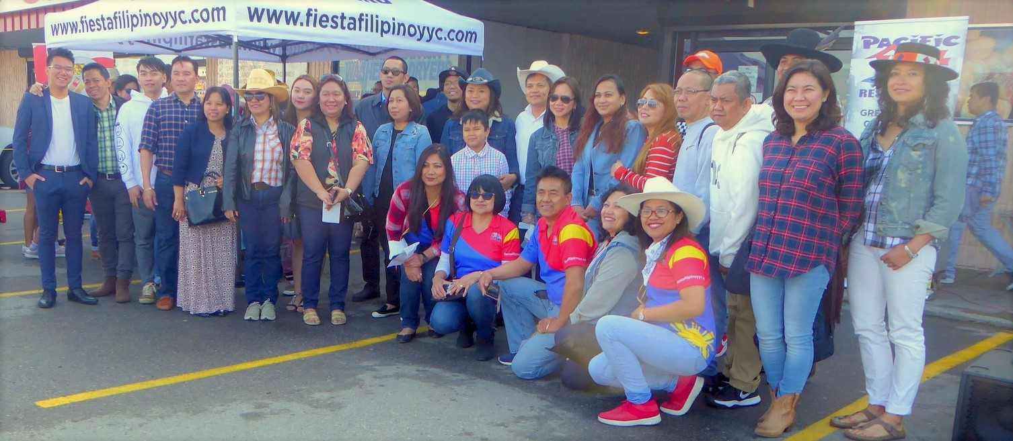
The officers, staff and family members of the Philippine Consulate General in Calgary with some of the members of Philippine Festival Council of Alberta during the Agahan Filipino Stampede Breakfast.

The officers and staff of the Philippine Consulate General in Calgary and their family members, led by Consul General Zaldy Patron, were among those who came and supported the Agahan.
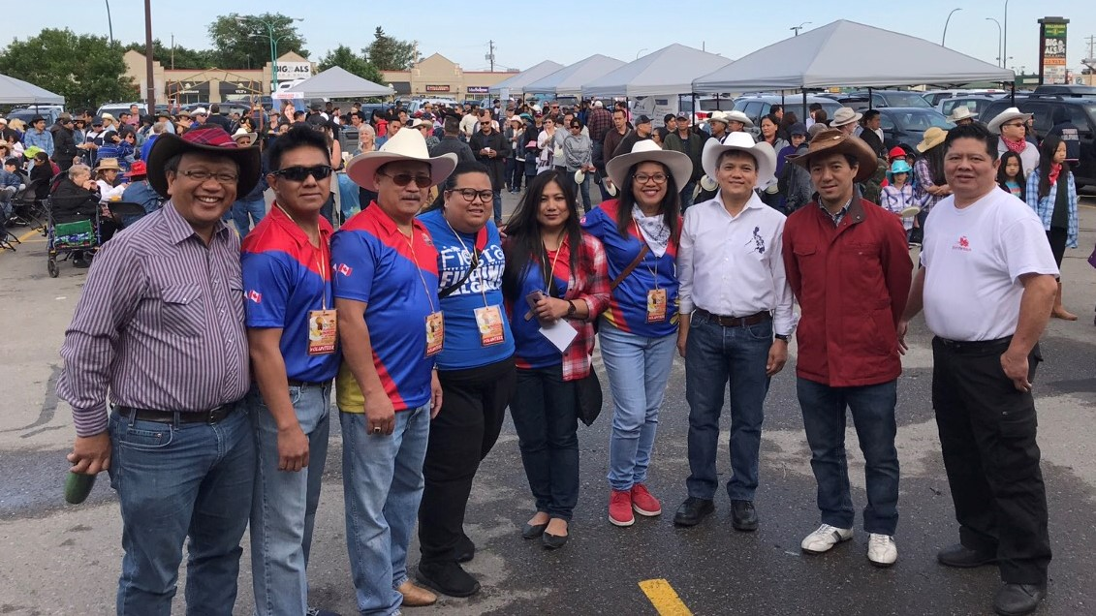
Consul General Zaldy Patron (3rd from right) with Japanese Consul Kohei Sakamoto (2nd from right) and the members of the Philippine Festival Council of Alberta during the Agahan Filipino Stampede Breakfast.

“I congratulate PFCA and its members and volunteers for successfully organizing this year’s Agahan. Through the Agahan, the Filipino community was able to show its solidarity with the Calgarians in their celebration of this 107-year-old Calgary Stampede tradition,” Consul General Patron said. He also pointed out that Agahan highlighted the hospitality of the Filipinos, which complemented the Calgarians’ own brand of hospitality during the Stampede season as friends, neighbors and strangers alike shared breakfast in different parts of the city. END.

