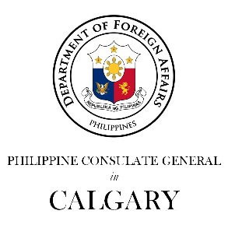

Philippine Consulate General in Calgary
PR- 23 - 2019 12 June 2019

PHILIPPINE CONSULATE GENERAL IN CALGARY HOSTS RECEPTION FOR THE 121ST ANNIVERSARY OF THE PROCLAMATION OF PHILIPPINE INDEPENDENCE AND 70TH ANNIVERSARY OF THE ESTABLISHMENT OF PHILIPPINES-CANADA DIPLOMATIC RELATIONS

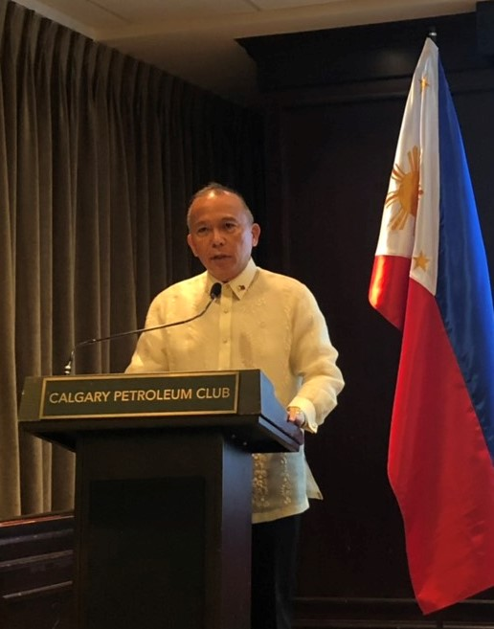
12 June 2019, Calgary, Alberta -- Consul General Gilberto Asuque led the officers and staff of the Philippine Consulate General in Calgary for the celebration of the 121st Anniversary of the Proclamation of Philippine Independence with a reception on 12 June 2019 at the Calgary Petroleum Club. The event also commemorated the 70th anniversary of the establishment of diplomatic relations between the Philippines and Canada.

The reception was a first for the Philippine Consulate General in Calgary, which opened in February 2016.

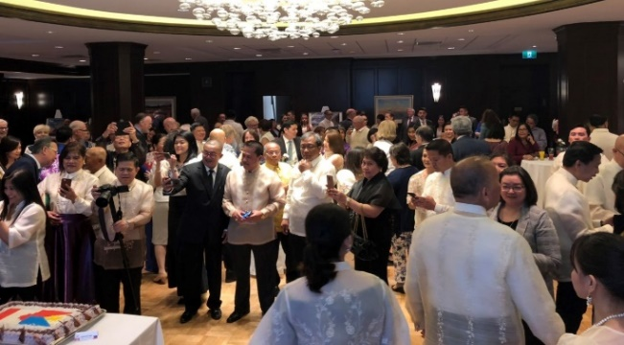
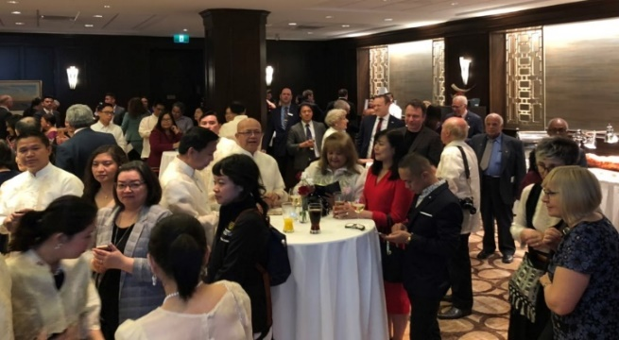
Addressing about 200 guests from the local government, consular corps, leaders of the Filipino community, the academe, and the business community, Consul General Asuque highlighted the significance of commemorating the proclamation of Philippine Independence in the history of the Filipino people. Quoting from the Independence Day message of Pres. Rodrigo Roa Duterte, the Consul General said that the path to independence was not without cost as it was “nourished by the sweat and blood of our patriots, heroes and martyrs.” The challenges faced by our forefathers emphasized the Filipino’s determination and sacrifice that led to the freedoms that we enjoy today, the Consul General added.
Consul General Asuque addresses some 200 guests at the CPC reception.

Guests at the reception include local government officials, members of the consular corps, academe, business community, and Filipino community leaders.

Consul General Asuque also recognized the contribution of the more than 950,000 Filipinos in Canada to the richness of Canadian culture and economy. Such contribution was also recognized in 2018 when the Government of Alberta and the federal government of Canada designated the month of June as “Philippine Heritage Month” that is celebrated through cultural events spearheaded by various Filipino community groups.
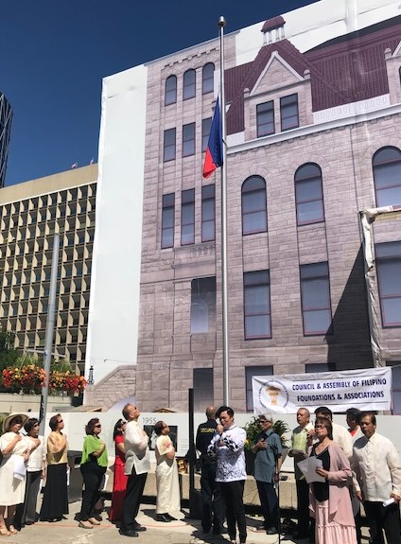
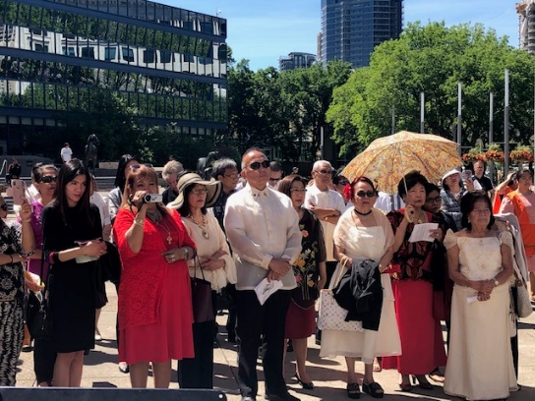
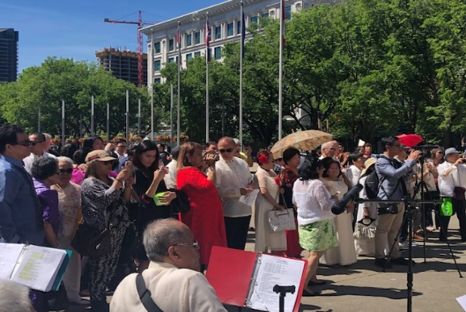
One such event was the flag-raising ceremony organized by the Council and Assembly of Filipino Federations and Associations (CAFFA) at the Calgary City Hall also on June 12. Consul General Asuque and all personnel of the Philippine Consulate General joined members and leaders of the Filipino community at the said flag-raising event.
The Philippine Consulate General, led by Consul General Asuque, joined the Filipino community’s Flag-Raising ceremony at the Calgary City Hall.

In his remarks at the Consular reception, the Consul General mentioned that after 70 years of friendship, the Philippines and Canada welcome the challenge of further strengthening and moving forward the bilateral relations. He also acknowledged the tireless efforts of personnel of the Philippine foreign service in working towards this end, as well as in providing consular services to Filipinos abroad including the over 175,000 Filipinos in the Province of Alberta with the over 75,000 Filipinos in Calgary and the over 33,000 Filipinos in the Province of Saskatchewan. The two provinces comprise the consular jurisdiction of PCG Calgary.
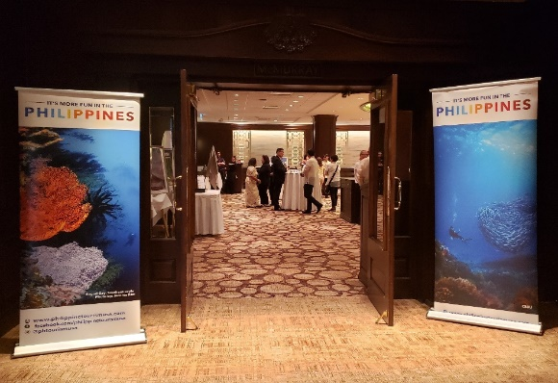

The reception also featured an exhibition of Philippine tourist destinations, while tourism videos projected on the main screen before and after the program showed guests the many beautiful attractions in the country.

The Calgary Petroleum Club is a historic, world-class facility that offers exclusive access to services including events for more than 70 years now. Historically, membership was made up primarily of oil and gas executives, but this has been extended to other industries and business establishments, including consular missions.
Mc Murray Room of the Calgary Petroleum Club with the tourism posters at the entrance of the June 12 reception of the PCG Calgary

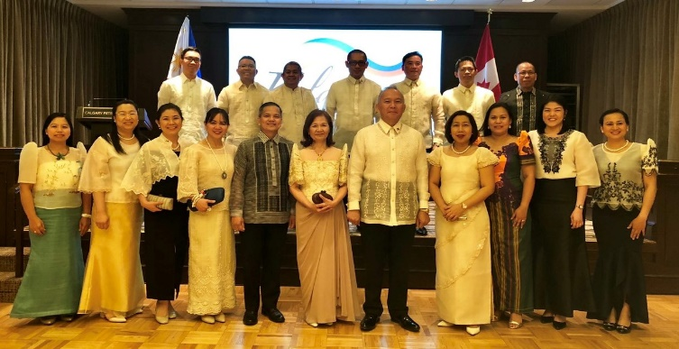
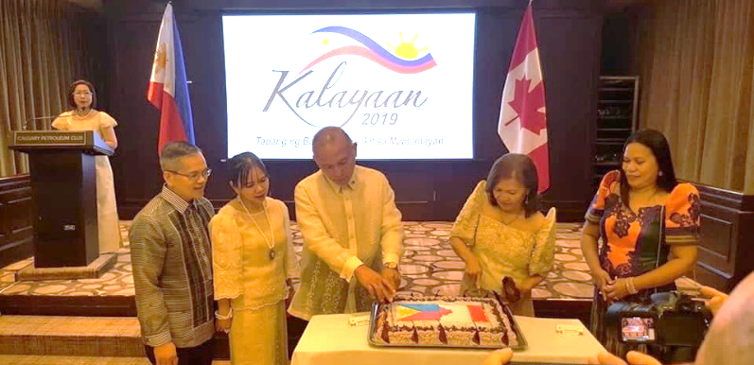
The reception included the cutting of the cake and capped with the photo of the entire officers and staff of the PCG Calgary. END

