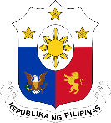
Philippine Consulate General, Calgary
Suite 920, 517 10th Ave SW, Calgary AB, T2R 0A8 ▪ Tel: 403-455-9346; 403-455-9457 ▪
Website: philcongencalgary.org

PR- 18 -2019

CALGARY HOSTS PH LABOR DAY
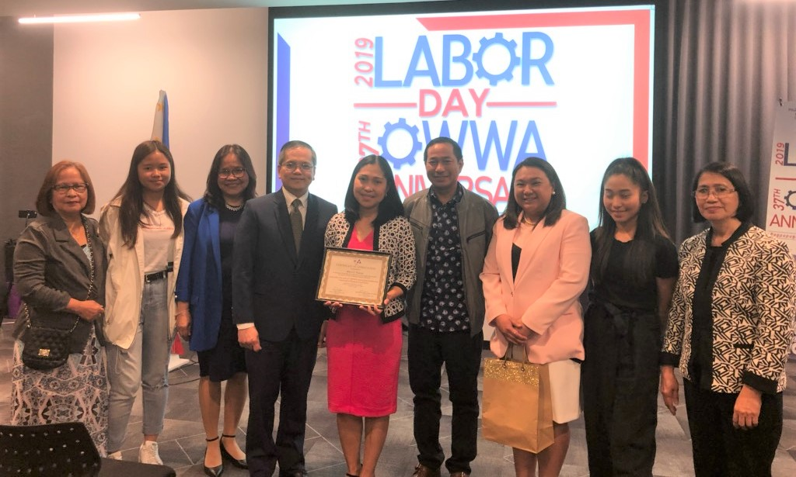
AND 37TH OWWA ANNIVERSARY CELEBRATION
Ms. Marvi Pascua (5th from left) receiving a certificate of appreciation after giving a testimonial about her struggles and triumphs as OFW in Alberta, Canada. She is joined by the members of her family and Deputy Consul General Zaldy Patron (4th from left), Labor Attaché Margarita Eugenia Victorino (3rd from right), OWWA Welfare Officer Lilia De Guzman (3rd from left) and Assistant Labor Attaché Olica Macawili (extreme right).

24 May 2019, Calgary – The Philippine Overseas Labor Office (POLO) and the Overseas Workers Welfare Administration (OWWA) in Vancouver and the Philippine Consulate General in Calgary jointly organized the celebration of the Philippine Labor Day and the 37th OWWA Anniversary in Calgary on 19 May 2019. Sixty-four (64) guests, including workers and community leaders, attended the event held at Alt Hotel in Calgary East Village.

The event featured the reading of the messages of Secretary Silvestre Bello III by Labor Attaché Margarita Eugenia Victorino and of OWWA Administrator Hans Cacdac by OWWA Welfare Officer Lilia De Guzman.

Deputy Consul General Zaldy Patron thanked POLO and OWWA in Vancouver for choosing Calgary as the venue for the twin celebrations. He lauded the contributions of the Filipino workers to both the Canadian and Philippine economies. He also called on them to continue to live up to the good reputation of Filipino workers that made them well-liked by their Canadian employers.

Part of the celebration was the testimonial given by Ms. Marvi Pascua, owner of Lighthouse Day Home in Edmonton, wherein she recounted her struggles and triumphs as an overseas Filipino worker in Alberta. A former teacher in the Philippines, she started working in Alberta as a nanny until she was able to put up her own day home. She continued studying and completed a Certificate in Immigration, Laws, Policies and Procedures from the University of British Columbia. She is now aiming to put her own Immigration Services office. While in Canada, she was diagnosed of cancer, but this did not deter her from pursuing her dream of landing a better job and career in Alberta.

Another highlight of the event was the launch of financial literary videos called Pinansyal na Talino at Kaalaman (PiTaKa) which were jointly produced by OWWA, Banco de Oro and Bangko Sentral ng Pilipinas. The videos encourage the OFWs to become OWWA members. Their families, on the other hand, are taught the value of saving in the bank part of the OFW’s remittances and prioritizing spending for the most important things like education, house, business and vehicle.

-END-

