PHILIPPINE CONSULATE GENERAL
Calgary

Philippine Consulate General in Calgary
PR- 26 - 2019 18 June 2019

PHILIPPINE CONSULATE GENERAL IN CALGARY CELEBRATES PHILIPPINE INDEPENDENCE WITH THE FILCOM IN CALGARY
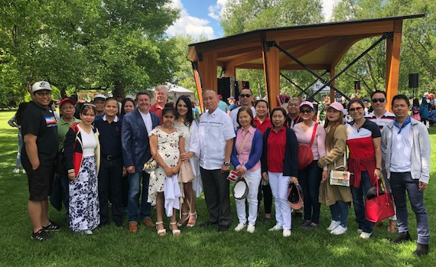
18 June 2019, Calgary, Alberta -- Consul General Gilberto Asuque and the entire personnel of the Philippine Consulate General joined in the celebration of the “3rd Sulong Kalayaan Picnic at the Park”, an event organized by the Philippine Independence Organizing Committee of Calgary – Sulong Kalayaan Society (PIOCC-SKS) on 16 June 2019 at Riley Park in Calgary.
Consul General Asuque with Honourable Rajan Sawhney, Minister of Community and Social Services (MLA for Calgary-North East), MLA Mickey Amery, PIOCC-SKS Chairmen Bryan Ymbang, and Philippine Consulate personnel.

The event was held to commemorate the 121st Anniversary of Philippine Independence and to celebrate Philippine Heritage Month. The Government of Alberta proclaimed June of each year as Philippine Heritage Month in recognition of the significant contributions of Filipino-Canadians to the “social, economic, cultural and historical richness of the Province of Alberta.” The House of Commons of the Federal Government of Canada also issued a resolution declaring June of each years as Philippine Heritage Month. There are more than 950,000 Filipinos in Canada.

PIOCC-SKS Chair Bryan Ymbang said PIOCC was established by SKS mainly to undertake activities in celebration of the anniversary of the proclamation of Philippine Independence in June. This year’s main event was “3rd Sulong Kalayaan Picnic at the Park”, which featured lechon and other Filipino cuisine, as well as Filipino music and dance through cultural performances by various talents from the community. (Photos below)

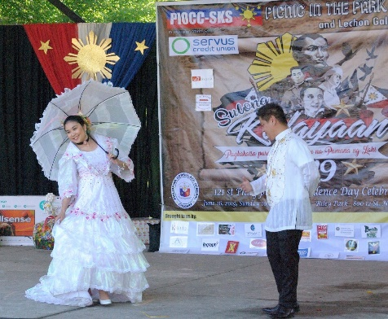
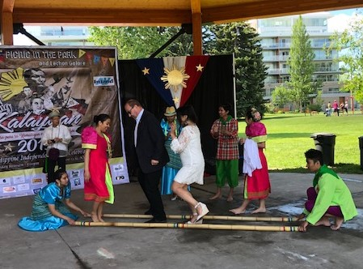
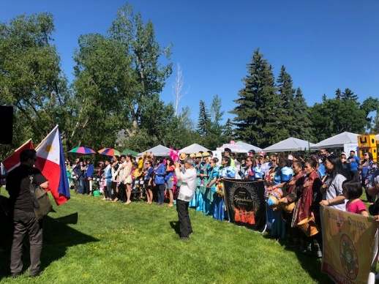
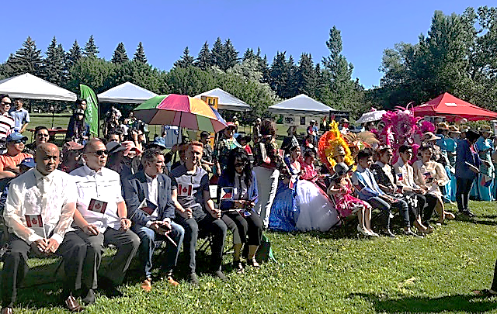
The event was graced by the presence of Members of the Legislative Assembly (MLA), namely, Honourable Leela Sharon Aheer, Minister of Culture, Multiculturalism and Status of Women (MLA for Chestermere-Strathmore); Honourable Ric McIver, Minister of Transportation, Infrastructure, and Jobs, Skills, Training and Labor (MLA for Calgary-Hays); Honourable Rajan Sawhney, Minister of Community and Social Services (MLA for Calgary-North East); Mr. Roger Reid (MLA for Livingstone-Macleod), and; Mr. Mickey Amery (MLA for Calgary-Cross). (Photo above)

In their speech, the MLAs all mentioned that the designation of June as Philippine Heritage Month highlights the importance and positive contribution of Filipinos in the fabric of Canadian society. END

