Philippine Consulate General, Calgary
Suite 920, 517 10th Ave SW, Calgary AB, T2R 0A8 ▪ Tel: 403-455-9346; 403-455-9457 ▪
Website: philcongencalgary.org

PR- 34 -2019

PCG CALGARY HOSTS
FREE PH FILM SHOWING

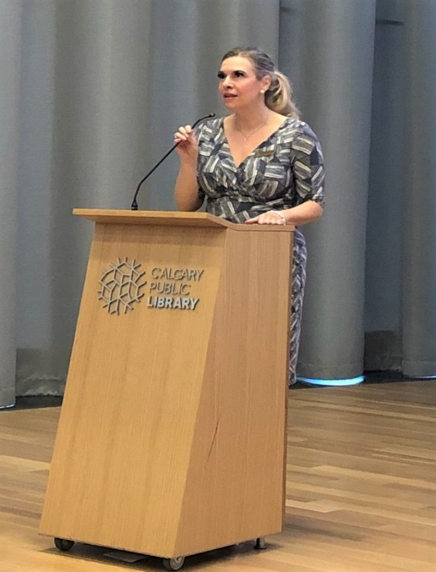
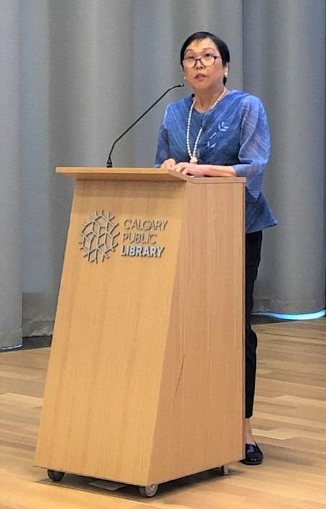
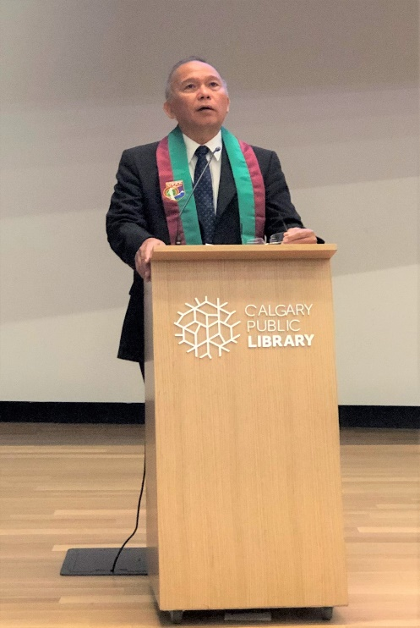
(L-R) Consul General Gilberto Asuque, Ambassador Petronila Garcia and Hon. Stephanie Kusie (Member of Parliament for Calgary Midnapore) delivering their remarks during the opening ceremony of the its 2019 Philippine Film Showing in Calgary on 22 June 2019.

29 June 2019, Calgary – The Philippine Consulate General (PCG) in Calgary successfully held its 2019 Philippine Film Showing in Calgary with the free screening of two Filipino indie films, namely, Kanana Kanu on 22 June and Anac Ti Pating on 29 June 2019.

Both films were finalists at the 2012 Sineng Pambansa National Film Festival held in Davao City, Philippines, with Anac Ti Pating awarded as the festival’s Best Picture.

The film screenings were held at the Patricia A. Whelan Performance Hall of the newly built Calgary Central Library in Downtown Calgary, Alberta, Canada.

Consul General Gilberto Asuque remarked that the PCG’s first cultural diplomacy project for 2019 was meant to highlight three important milestones this year - the 121st Anniversary of the Proclamation of Philippine Independence on 12 June, the Philippine Heritage Month being celebrated in Canada in June, and the 70th Anniversary of Philippines-Canada Diplomatic Relations.

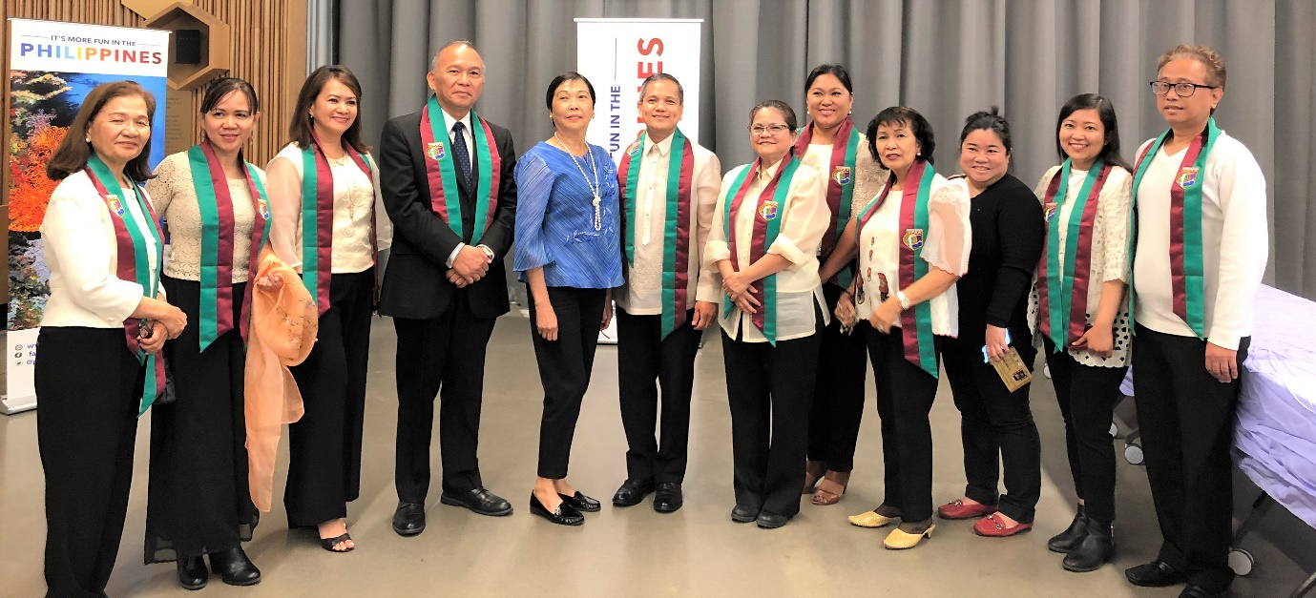
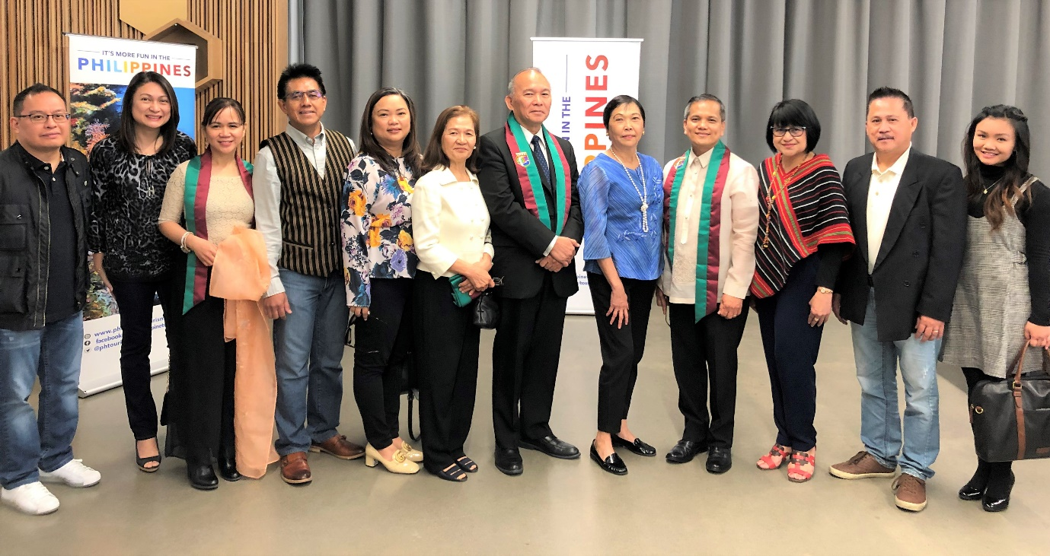
Consul General & Mrs. Gilberto Asuque, Ambassador Petronila Garcia and Deputy Consul General and Mrs. Zaldy Patron join the members of the UP Alumni Association of Alberta (top) and the Philippine Festival Council of Alberta (bottom) during the opening of the 2019 Philippine Film Showing in Calgary on 22 June 2019.

H.E. Petronila Garcia, Philippine Ambassador to Canada, and the Hon. Stephanie Kusie, Member of Parliament (MP) for Calgary Midnapore (Alberta) were the event’s guests of honor during the opening ceremony on 22 June.

The PCG organized the event in partnership with the Film Development Council of the Philippines, UP Alumni Association of Alberta, Calgary Public Library and Philippine Festival Council of Alberta. END

