Philippine Consulate General, Calgary
Suite 920, 517 10th Ave SW, Calgary AB, T2R 0A8 ▪ Tel: 403-455-9346; 403-455-9457 ▪
Website: philcongencalgary.org

PR- 44 -2019

WINTER ESCAPADE 7 LAUNCHED
IN SASKATOON, SASKATCHEWAN

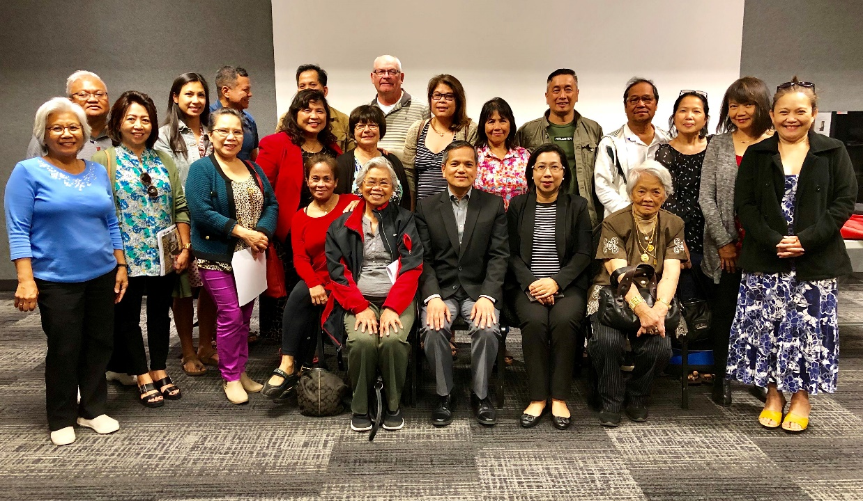

Consul General Zaldy Patron (seated, center) and Consul Pamela Durian-Bailon (seated, 2nd from right) with Filipino community leaders during the launching of Winter Escapade 7 in Saskatoon, Saskatchewan on 3 September 2019.

6 September 2019, Calgary – Consul General Zaldy B. Patron launched the Winter Escapade 7 travel tour to the Philippines in Saskatoon, Saskatchewan on 3 September 2019 at the Cosmo Civic Centre, Saskatoon with the assistance of the Filipino-Canadian Association of Saskatoon (FilCAS).

During the launch, Consul General Patron gave a briefing about Winter Escapade 7 Tour to Philippines on 15-22 January 2020. The tour will bring the participants to the different tourist destinations in Manila, Bataan, Pampanga, and Boracay where they can expect to receive VIP treatment from the tour organizers. The participants will be billeted in the finest hotels in the Philippines, treated to savory Filipino dishes, and introduced to the Filipino hospitality. They will likewise enjoy the beautiful beaches, interesting museums, and fascinating heritage sites in the Philippines. Interested participants may get more information about Winter Escapade 7 and register at www.winterescapadeph.com.

Consul General Patron also launched Winter Escapade 7 in Edmonton on 25 August and in Calgary on 28 August, two major cities in the Province of Alberta.

