Philippine Consulate General, Calgary
Suite 920, 517 10th Ave SW, Calgary AB, T2R 0A8 ▪ Tel: 403-455-9346; 403-455-9457 ▪
Website: philcongencalgary.org

PR- 55 -2019

PCG CALGARY DELIVERS CONSULAR SERVICES TO FILIPINOS IN FORT MCMURRAY, ALBERTA

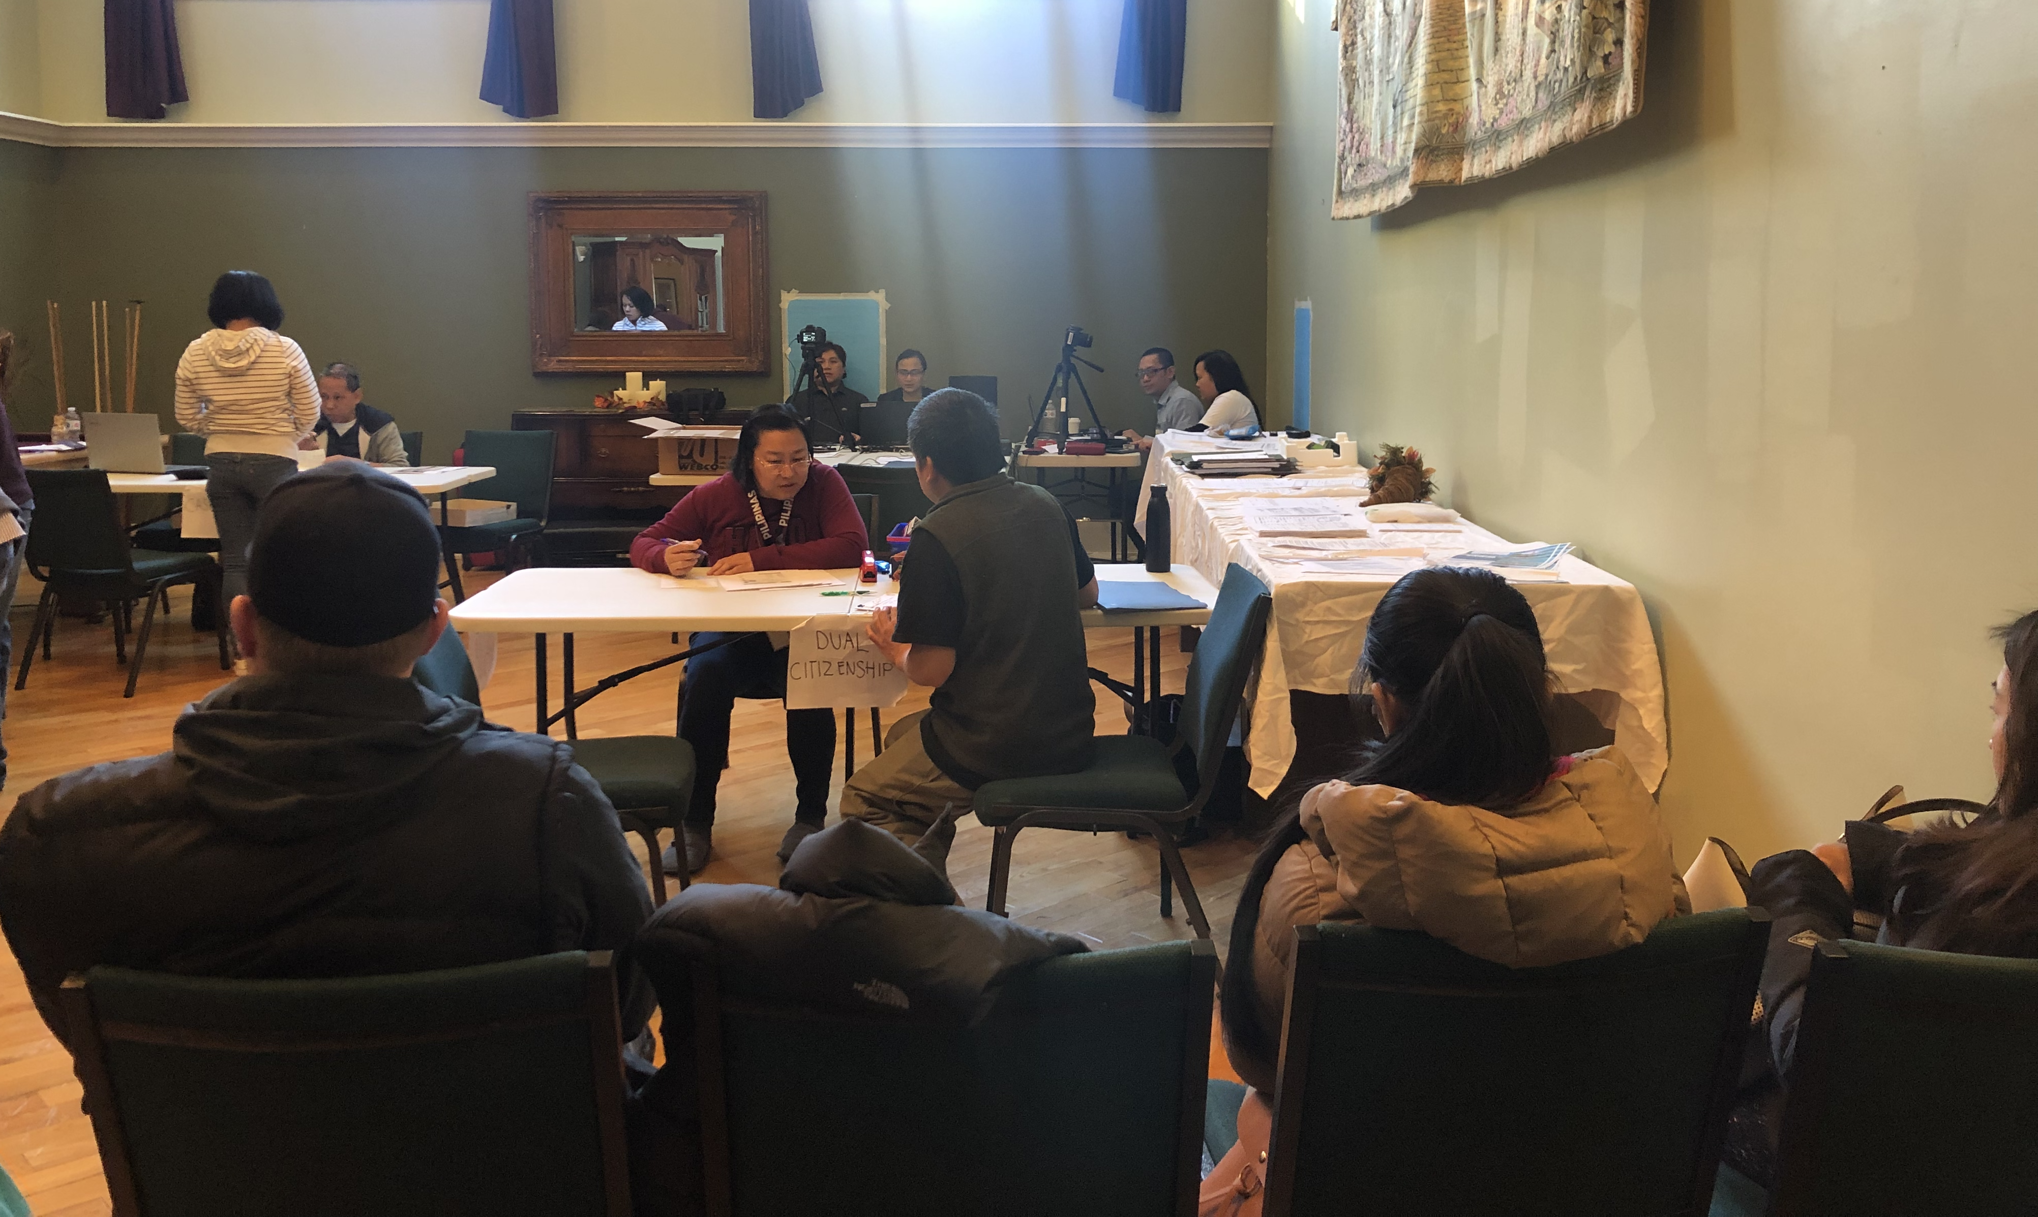

PHOTO: As part of providing consular services to Filipino nationals overseas, the Philippine Consulate General in Calgary conducted a consular outreach in Fort McMurray in Alberta, Canada on 1-3 November 2019.

4 November 2019, Calgary – The Philippine Consulate General in Calgary conducted a consular outreach mission in Fort McMurray, Alberta, Canada on 1-3 November 2019. Tthe six-member consular team, headed by Consul Pamela Durian-Bailon, provided a total of 457 passport, notarial, NBI clearance renewal, civil registration, visa, and RA 9225 application services.

Consul Durian-Bailon also administered the Oath of Allegiance of twenty-four (24) Filipino-Canadians who retained or reacquired their Philippine Citizenship after being naturalized as Canadians.

According to the 2016 Canada Census, there are about 4,990 Filipinos in Fort McMurray, which is over 700 kilometers away from Calgary. END

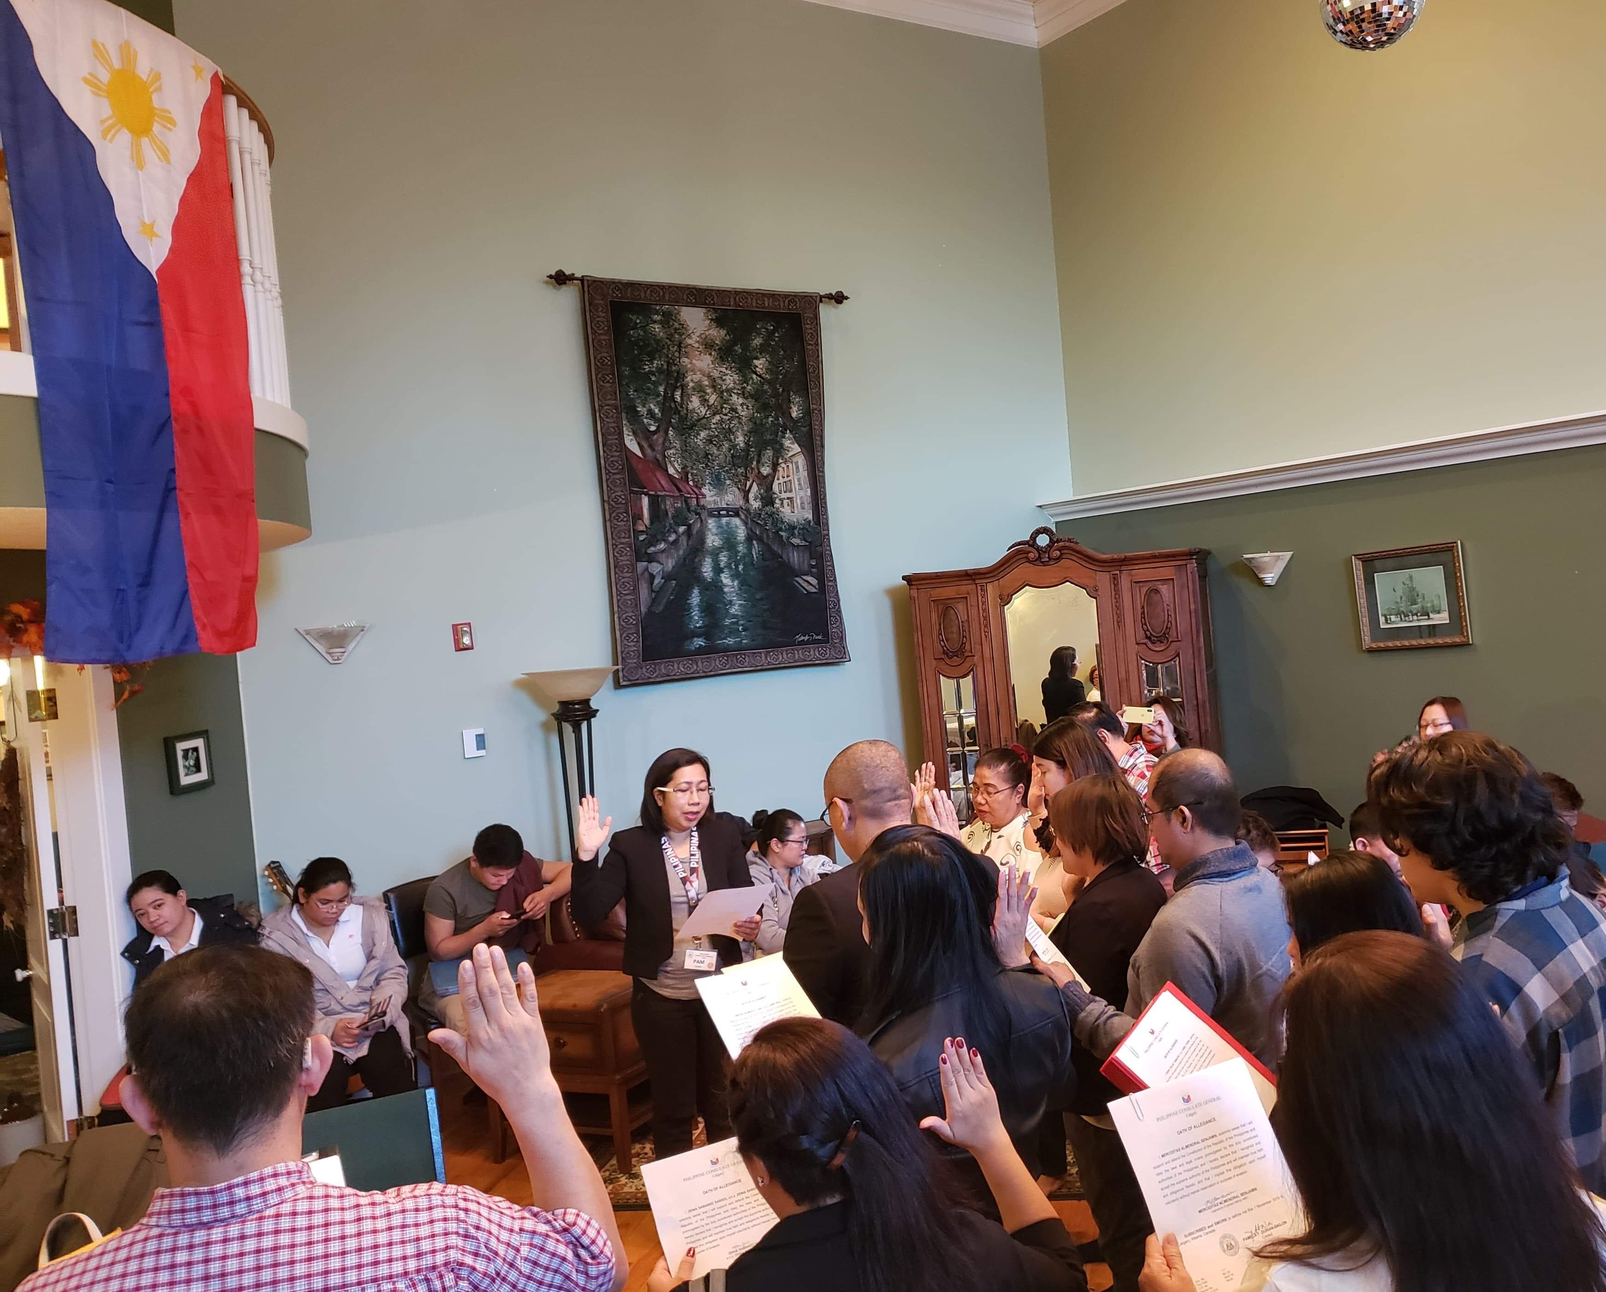

PHOTO: Consul Pamela Durian-Bailon, who headed the consular team in Fort McMurray on 1-3 November 2019, administers the Oath of Allegiance of the Filipino-Canadian citizens who have reacquired or retained their Philippine citizenship at the consular outreach.

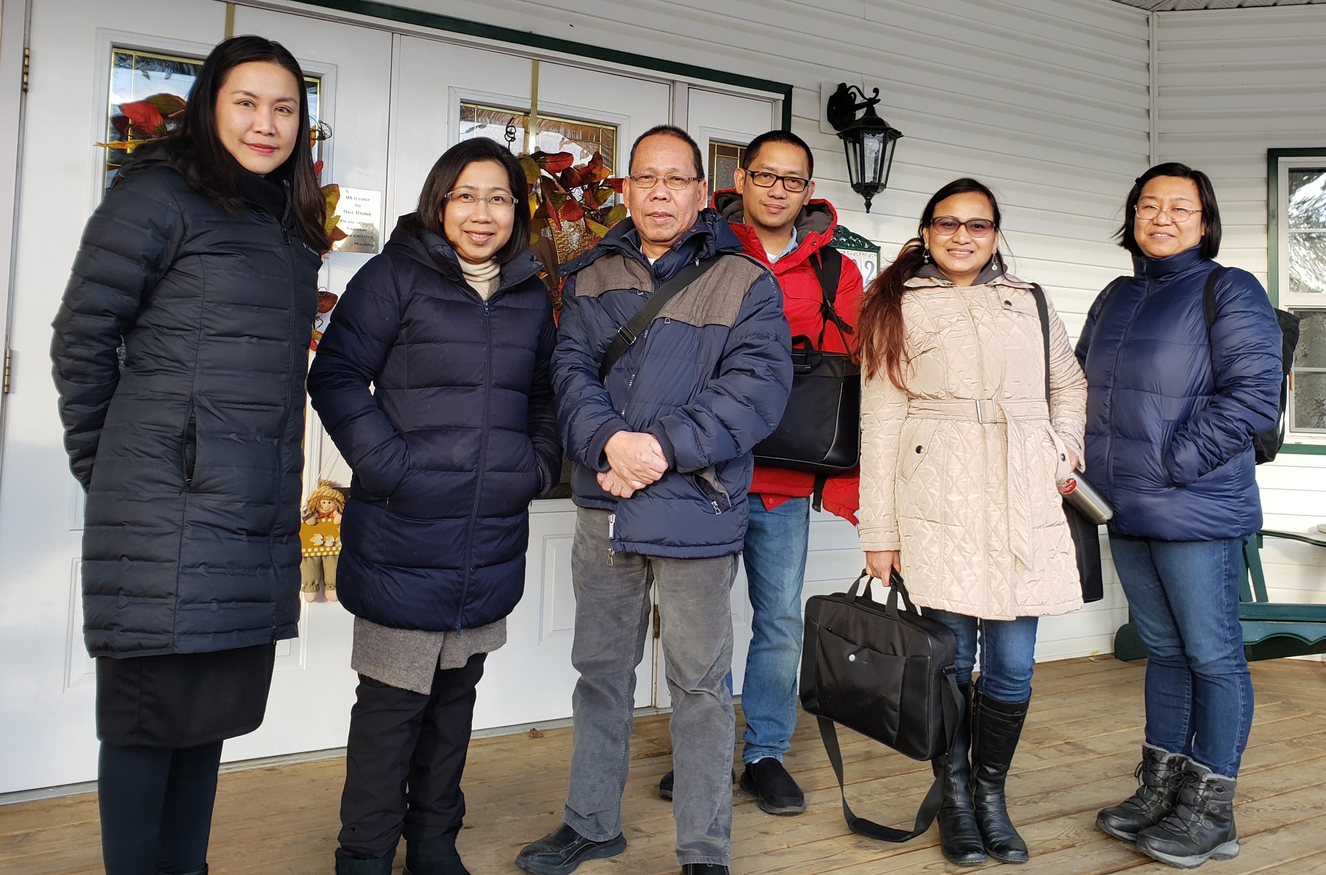
PHOTO: Consul Pamela Durian-Bailon (2nd from left), is pictured with the Consular Outreach Team, 3 November 2019.

