Philippine Consulate General, Calgary
Suite 920, 517 10th Ave SW, Calgary AB, T2R 0A8 ▪ Tel: 403-455-9346; 403-455-9457 ▪
Website: philcongencalgary.org

PR- 30 -2019

PCG CALGARY AND PCG TORONTO TRADE OFFICE CONDUCT
PH TRADE & INVESTMENT FORUMS IN CALGARY AND EDMONTON
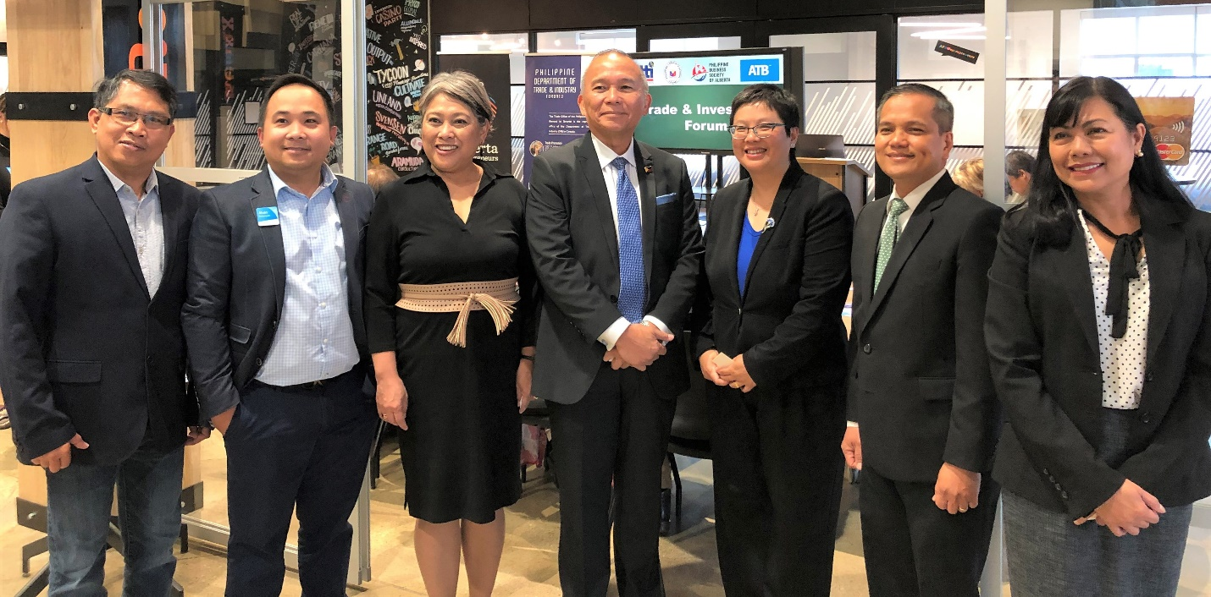
(L-R) Mr. Celso Andrade (President, Philippine Business Society of Alberta), Mr. Alvin Bustamante (ATB Financial), Senior Trade Commissioner Maria Roseni Alvero, Consul General Gilberto Asuque, Ms. Nancy Wu (Executive Director, Asia Pacific Branch, Alberta Economic Development, Trade and Tourism), Deputy, Consul General Zaldy Patron and Ms. Marjorie Newman during the PH Trade and Investment Forum in Edmonton, Alberta on 20 June 2019.

27 June 2019, Calgary – The Philippine Consulate General (PCG) in Calgary and the PCG Toronto Trade Office, led by Senior Trade Commissioner (STC) Maria Roseni Alvero, co-organized two Philippine Trade and Investment Forums held in Calgary and Edmonton, two major cities in the Province of Alberta, Canada, on 18 June and 20 June 2019, respectively.

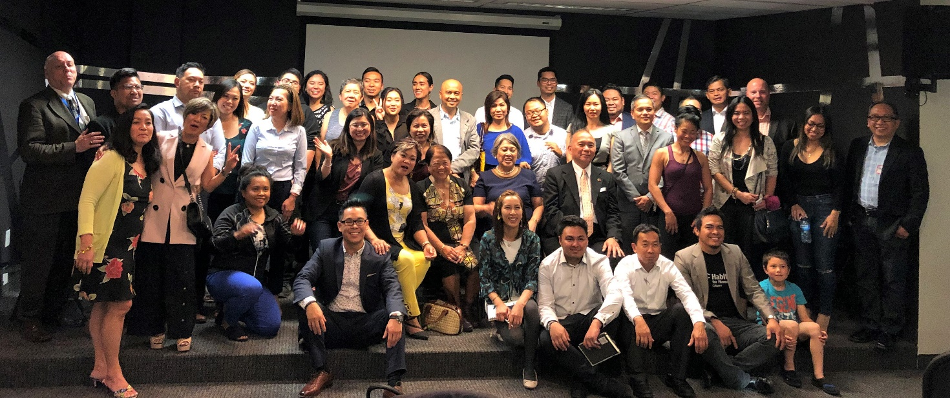
Consul General Gilberto Asuque, Deputy, Consul General Zaldy Patron and Senior Trade Commissioner Maria Roseni Alvero join the members and guests of the Filipino Chamber of Commerce of Alberta at the end of the PH Trade and Investment Forum in Calgary, Alberta on 18 June 2019.

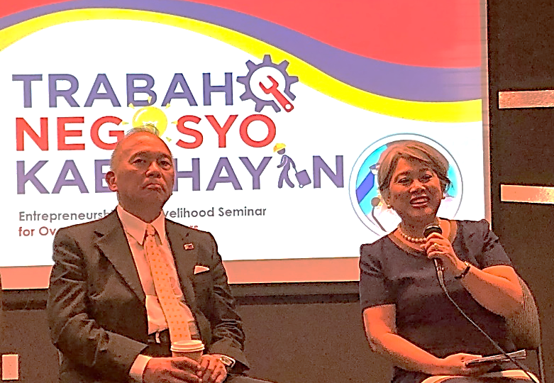
In Calgary, the PCG Calgary and STC Alvero partnered with the Filipino Chamber of Commerce of Alberta (FCCA) in organizing the forum that attracted 60 guests. In Edmonton, about 40 attendees came to the event held at the ATB Entrepreneur Center and co-hosted by the Philippine Business Society of Alberta (PBSA) and the ATB Financial.
In both events, STC Alvero gave a presentation on Trabaho, Negosyo, Kabuhayan (TNK) Entrepreneurship and Livelihood program of the Philippine Department of Trade Industry (DTI). She highlighted the Philippines’ economic performance and growth industries in country. She encouraged the participants to become entrepreneurs and invest in the Philippines. STC Alvero explained the services that the DTI extends to micro-, small-, and medium-size enterprises (MSMEs) as well as the investment opportunities in franchising business, start-ups, e-commerce, agri-tourism, and the makapuno industry in the Philippines.
Consul General Asuque and STC Alvero reply to questions during the Trade and Investment Forum
During the forum in Calgary, the PCG Calgary promoted its annual Winter Escapade tour to the Philippines and the YouLead program of the Commission on Filipinos Overseas.
In Edmonton, aside from STC Alvero, two provincial government officials also spoke at the forum. They were Mr. Ben Broadhead, Ministerial Assistant at the Economic Development, Trade and Tourism (EDTT) of Alberta, and Ms. Nancy Wu, Executive Director, Asia Pacific Branch, EDTT. Ms. Wu discussed Alberta’s exports to Asia Pacific and the investments of Asia-Pacific countries in Alberta. According to her, Alberta’s priority sectors in the Asia Pacific are energy, agri-food, forestry, petrochemicals, tourism and education. END.
Consul General Gilberto Asuque and Senior Trade Commissioner Maria Roseni Alvero during the session of the PH Trade and Investment Forum in Calgary, Alberta on 18 June 2019.

