Philippine Consulate General, Calgary
Suite 920, 517 10th Ave SW, Calgary AB, T2R 0A8 ▪ Tel: 403-455-9346; 403-455-9457 ▪
Website: philcongencalgary.org

PR- 25 -2019

CONSUL GENERAL ASUQUE GRACES
SCREENING OF “ULAM: MAIN DISH” IN CALGARY

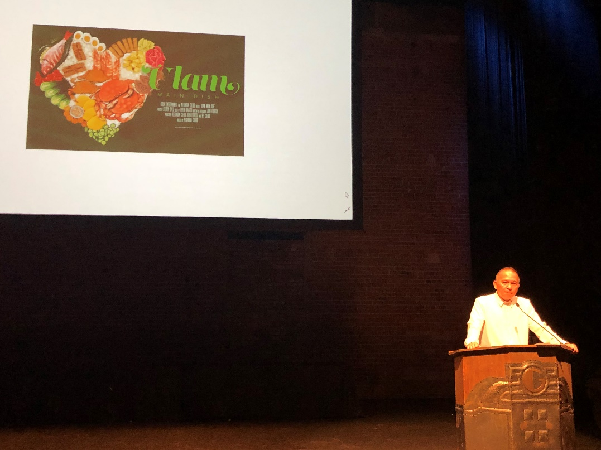
Consul General Gilberto Asuque gives his remarks at the screening of “Ulam: Main Dish” at the Grand Theater in Calgary on 16 June 2019.

17 June 2019, Calgary – Consul General Gilberto Asuque graced the screening of the food documentary film “Ulam: Main Dish” at the historic Grand Theater in Calgary (built in 1912) on 16 June 2019.

Organized by the Filipino Chamber of Commerce of Alberta (FCCA), in partnership with TGIF Films and the Trade Office of the Philippine Consulate General in Toronto, the ticketed event attracted about 360 viewers who watched the film about the rise of the Filipino food movement in the U.S. based on the stories of the chefs and Filipino restaurant owners in New Yok City and Los Angeles City in the U.S.A.

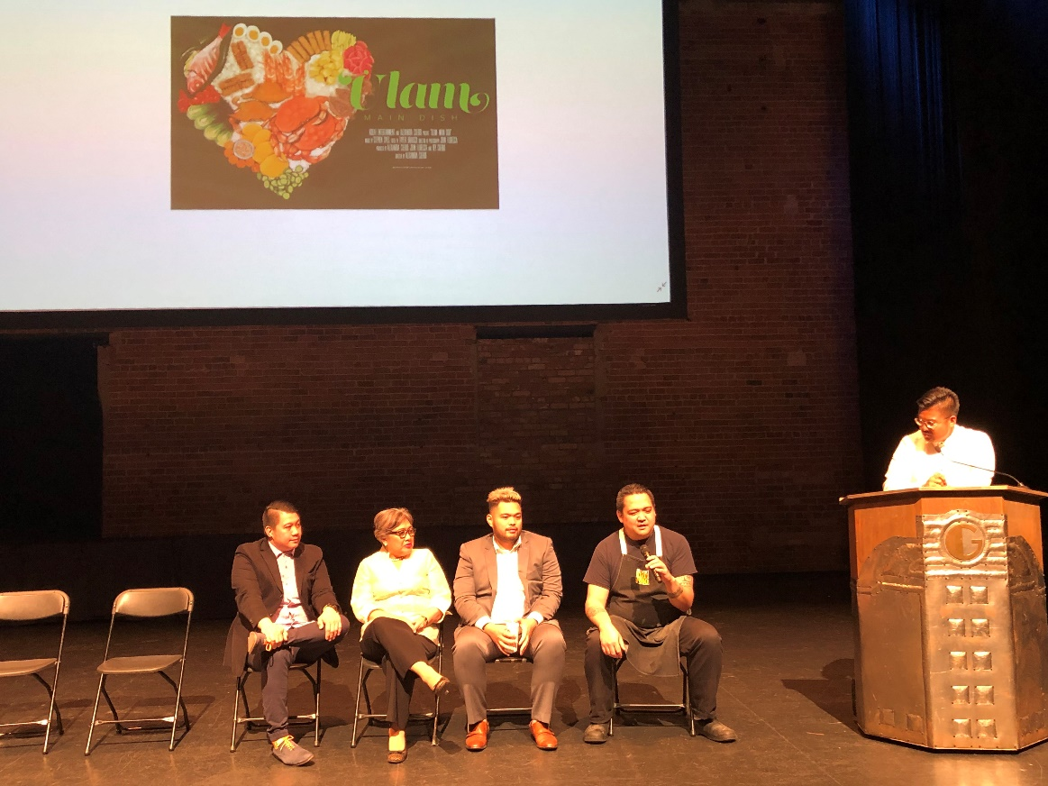
Panel discussion with Filipino chefs Jay Del Corro, Jeffrey Carlos and Jose Battad, Senior Trade Commissioner Maria Roseni Alvero and moderator Brian Morales at the end of the screening of “Ulam: Main Dish.”

The film screening was preceded by cocktail reception and networking session where guests were treated to samplings of Filipino foods, such as lechon (roasted pig), kinilaw (ceviche), and pork adobo.

At the end of the film showing, three Filipino chefs, namely, Jay Del Corro, Jeffrey Carlos and Jose Battad, and Senior Trade Commissioner Maria Roseni Alvero composed a panel that answered questions from the moderator and the audience.

Consul General Asuque thanked FCCA President Michael Siervo and his members for successfully organizing the event. The Consul General highlighted the significance of promoting Filipino food and dishes during the Philippine Heritage Month celebrations in Calgary and the province of Alberta in June to create greater awareness about the Filipinos’ rich contribution to the political, economic, cultural and social fabric of Alberta and Canada.

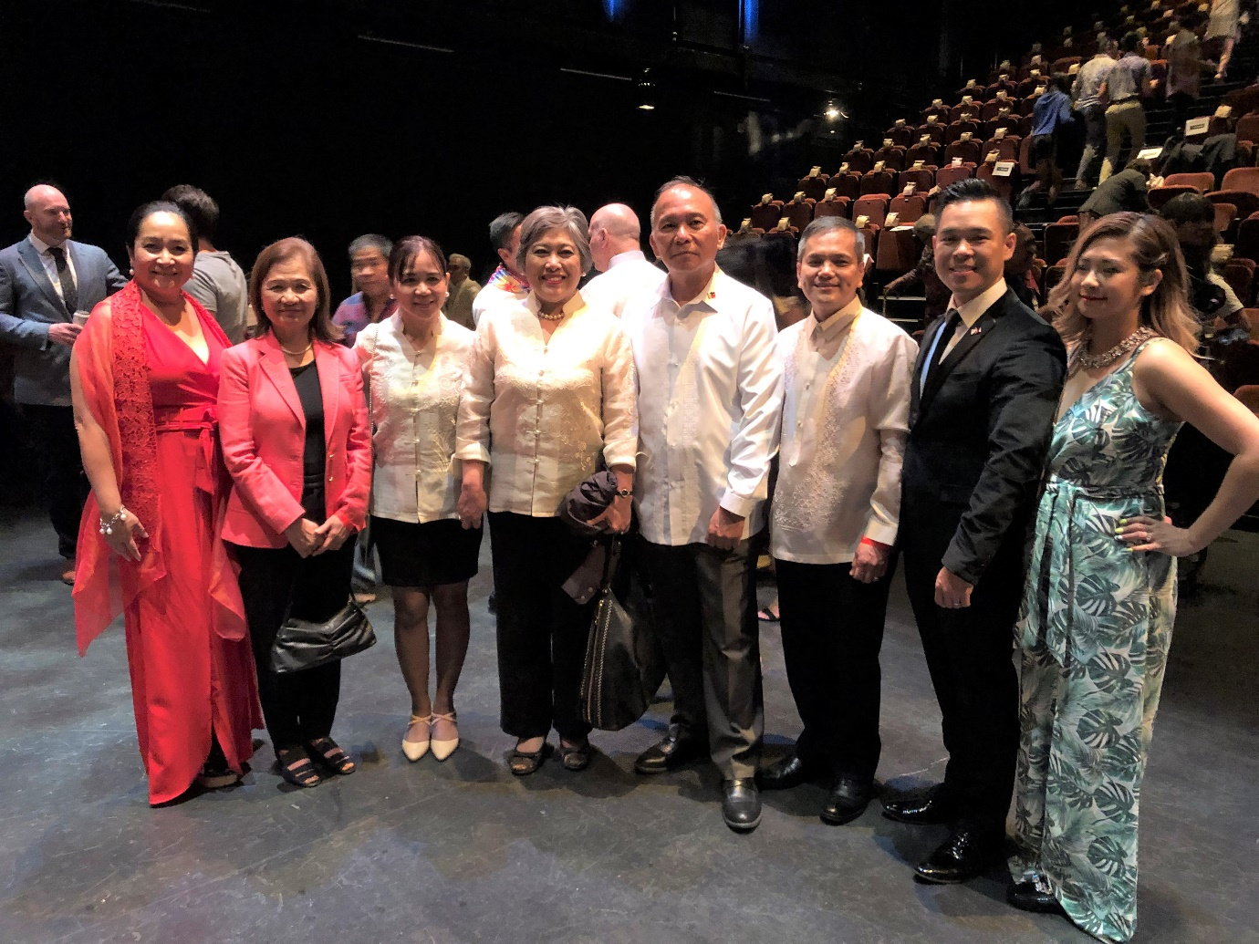
(L-R) Ms. Tess Ala of the Filipino Chamber of Commerce of Alberta (FCCA), Mrs. Rosalie Asuque, Mrs. Sheila Patron, Senior Trade Commissioner Maria Roseni Alvero, Consul General Gilberto Asuque, Deputy Consul General Zaldy Patron, FCCA President Michael Siervo and Mrs. Vivienne Siervo during the cocktail reception of the screening of “Ulam: Main Dish” at the Grand Theater in Calgary.

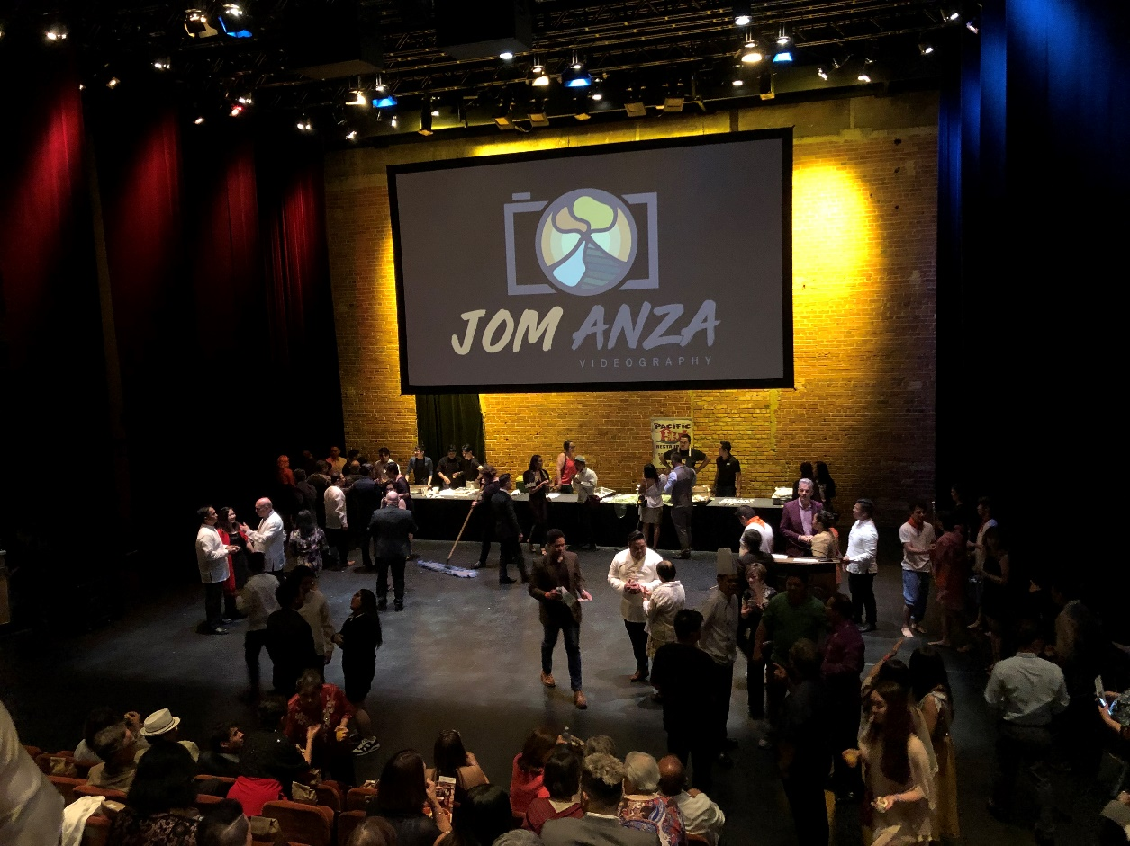
Cocktail reception of the screening of “Ulam: Main Dish” at the Grand Theater in Calgary.

