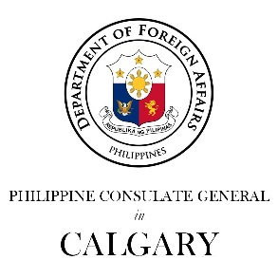

Philippine Consulate General in Calgary
PR- 14 - 2019 04 May 2019

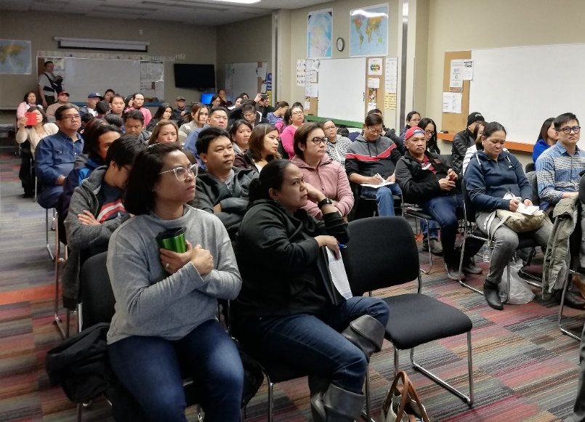
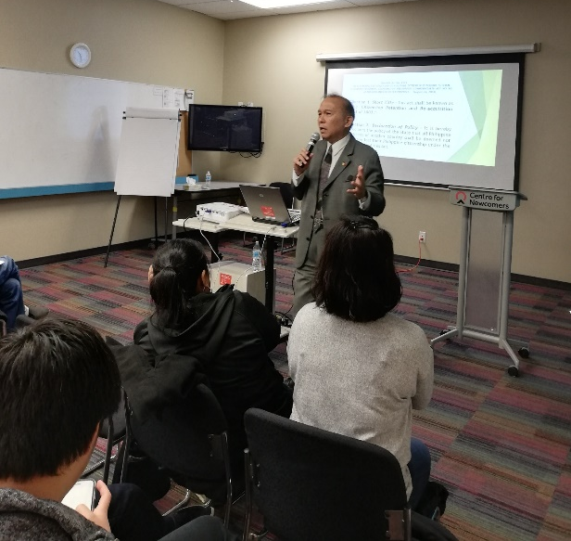
CONSUL GENERAL INFORMS FILIPINO-CANADIANS ON REACQUISITION OF PHILIPPINE CITIZENSHIP
04 May 2019, Calgary – Consul General Gilberto Asuque conducted a briefing for Filipinos and Filipino-Canadians in Calgary on the policy and process to reacquire Philippine citizenship under R.A. 9225.

The briefing was held at the Center for Newcomers and attended by some 60 Filipino migrants and Filipino-Canadians who expressed interest to know more about RA 9225 or “An Act Making the Citizenship of Philippine Citizens Who Acquire Foreign Citizenship Permanent. Amending for the Purpose Commonwealth Act. No. 63, As Amended and for Other Purposes.”

The briefing covered details of RA 9225 and the requirements as well as the process to apply for the reacquisition of Philippine citizenship. Filipino parents of children born in Canada were also advised that their children are Filipino citizens as provided in the Philippine Constitution and the birth must be reported to the Consulate General so that a Philippine birth certificate will be issued by the Philippine Statistics Authority, as basis for the issuance of a Philippine passport.

The participants expressed appreciation for the briefing by the Consul General, which gave them a better understanding of their option under RA 9225. Consul General Asuque conveyed his appreciation of Mr. Dario Ontolan, Settlement Manager, Center for Newcomers, for organizing the meeting with the Filipinos as he assured him that the Consulate General welcomes all opportunities to speak with the community at any forum. END

