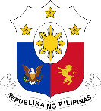
Philippine Consulate General, Calgary
Suite 920, 517 10th Ave SW, Calgary AB, T2R 0A8 ▪ Tel: 403-455-9346; 403-455-9457 ▪
Website: philcongencalgary.org

PR- _52__ -2019

PCG CALGARY CONDUCTS COMMUNITY FORUM,
PASSPORT SERVICES IN OKOTOKS, ALBERTA

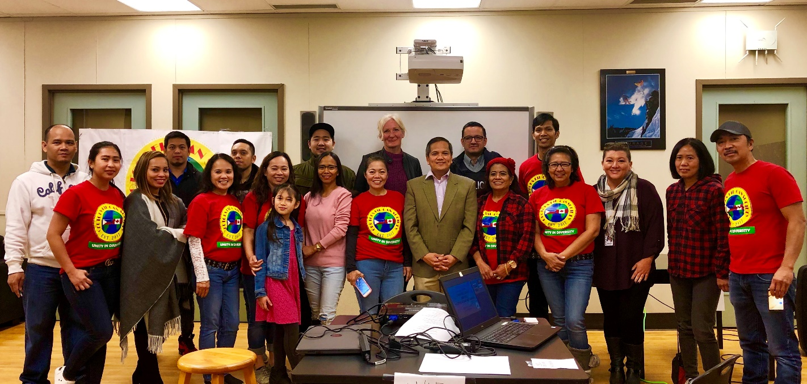
Consul Zaldy Patron (middle, in green jacket), together with the speakers at the Community Forum and the officers of the Okotoks Fil-Can Society, 28 September 2019.

30 September 2019, Calgary – The Philippine Consulate General (PCG), in partnership with the Okotoks Fil-Can Society, organized a Community Forum in Okotoks, Alberta on 28 September 2019.

The community forum was held to make the Filipinos in Okotoks aware of the various social services available to them in their town. As of 2016, Okotoks had a population of about 29,000, around 785 (2.7%) of them were Filipinos.
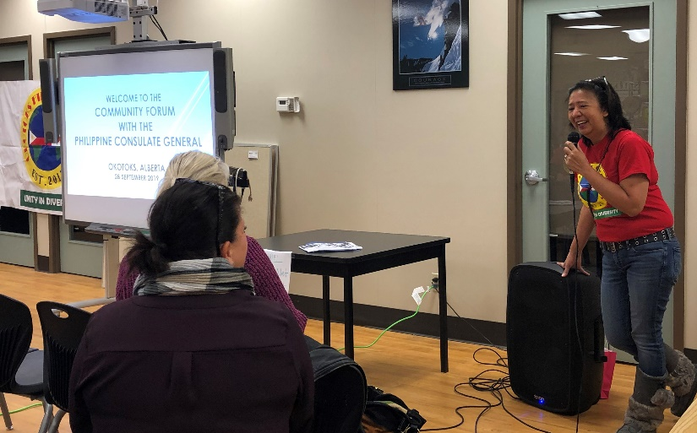
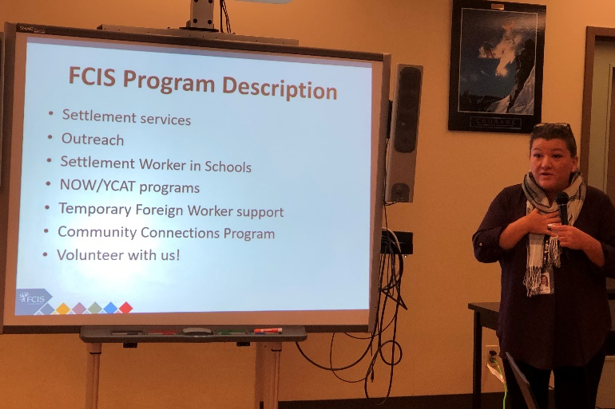
Left photo: Mrs. Norayda Ramsey, President, Okotoks Fil-Can Society. Right photo: Ms. Nancy Risdon of Foothills Community Immigration Services.

Ms. Nancy Risdon talked about the services that Foothills Community Immigration Services (FCIS) extends to newly-arrived immigrants. Newly-arrived Filipinos in Okotoks can apply for settlement services and temporary foreign worker support from the FCIS.

Ms. Sherri Mulen of Okotoks Family Resource Center (OFRC) explained the social services available for all residents of Okotoks. These services include; a) community access programs, such as subsidized taxi service, for senior citizens over 60 years old and persons with disabilities; b) training and community education around elder abuse; and c) financial support programs, such as recreation fee assistance, referrals to food bank, baby supplies village and summer camp.
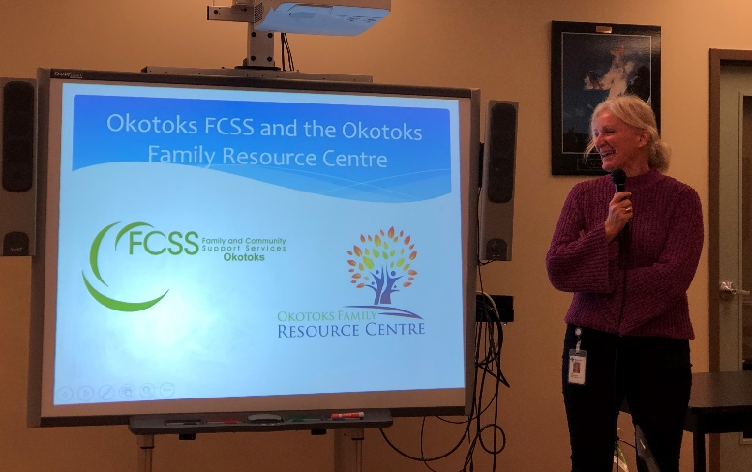
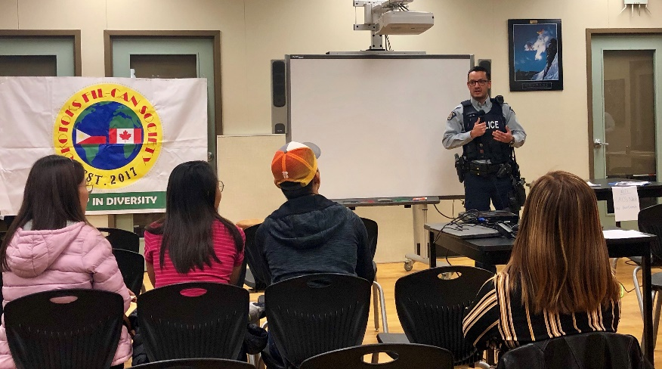
Left photo: Ms. Sherri Mulen of Okotoks Family Resource Center. Right photo: Cst. Castro Guerrero of Royal Canadian Mounted Police.

Cst. Castro Guerrero of Royal Canadian Mounted Police spoke about the problem of bullying, drugs and gang violence. He said that there were very minimal cases of illegal drug peddling and gang violence in Okotoks, which make the town relatively a safer place to live in.

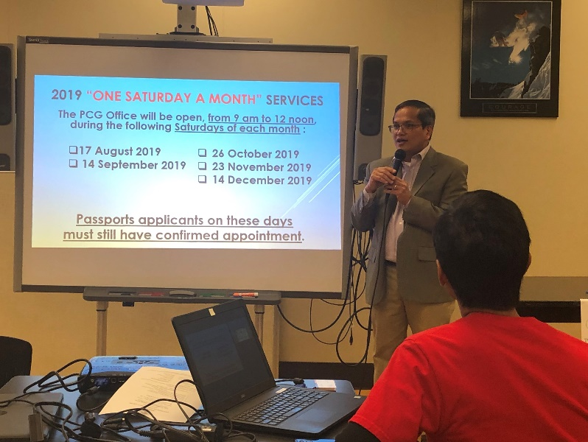
Consul General Zaldy Patron discussing the PCG’s consular services.
Consul General Zaldy Patron, on the other hand, explained in detail the consular services that the PCG provides to the Filipino nationals. He also promoted the Winter Escapade 7, the travel tour that will take place in Manila, Bagac in Bataan, Clark in Pampanga, and Boracay on 15-22 January 2020.

The PCG also processed a total of 49 passport applications along side the Community Forum.

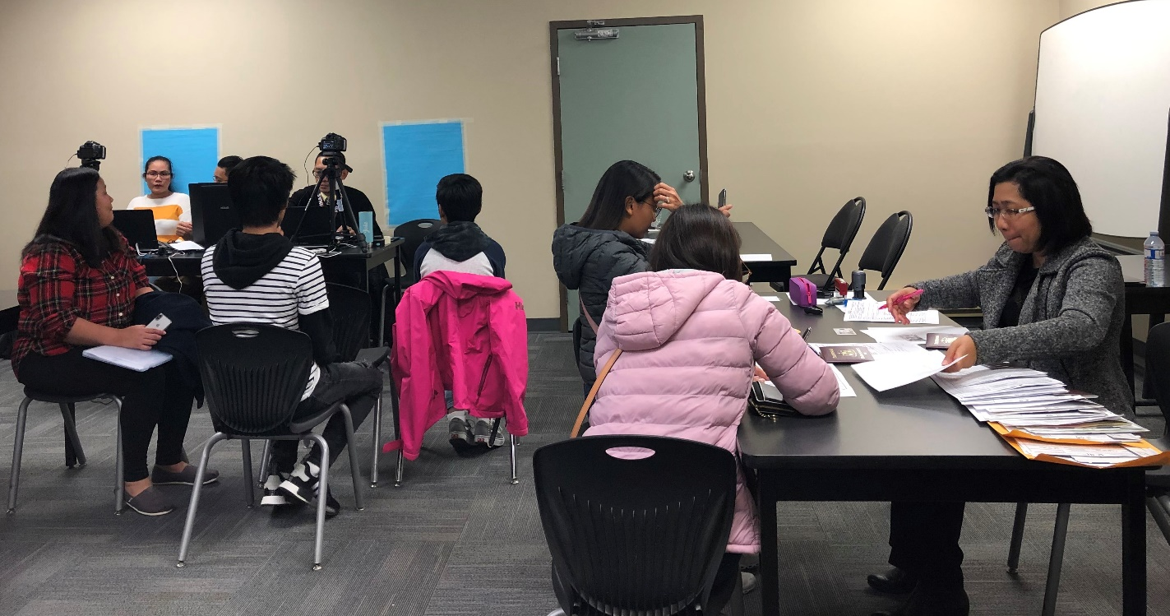
The PCG team providing passport services in Okotoks, Alberta on 28 September 2019.

