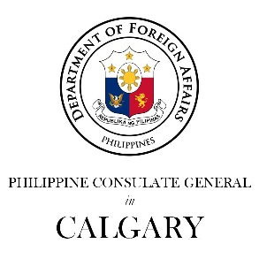

Philippine Consulate General in Calgary
PR- 31 - 2019 27 June 2019

CONSUL GENERAL ASUQUE JOINS IN THE CELEBRATION
OF CANADIAN MULTICULTURALISM DAY
Consul General Asuque delivers his remarks at the Multicultural Fiesta organized by the Calgary Catholic Immigration Society.
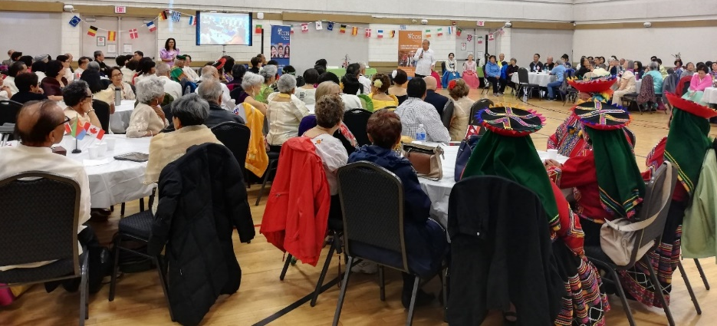
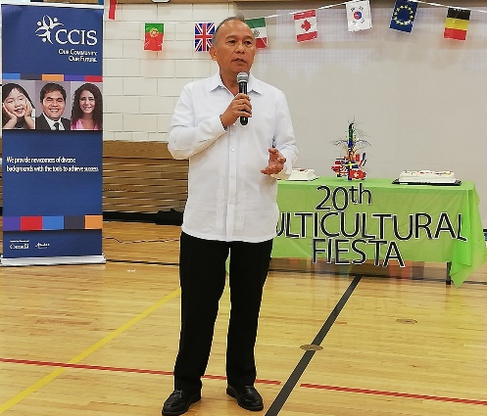
27 June 2019, Calgary – Consul General Gilberto Asuque joins various ethnic groups in their celebration of the Canadian Multiculturalism Day stressing the valuable contributions of the Filipino community in Alberta to the country-wide program to promote mutual understanding and respect among peoples of all background.

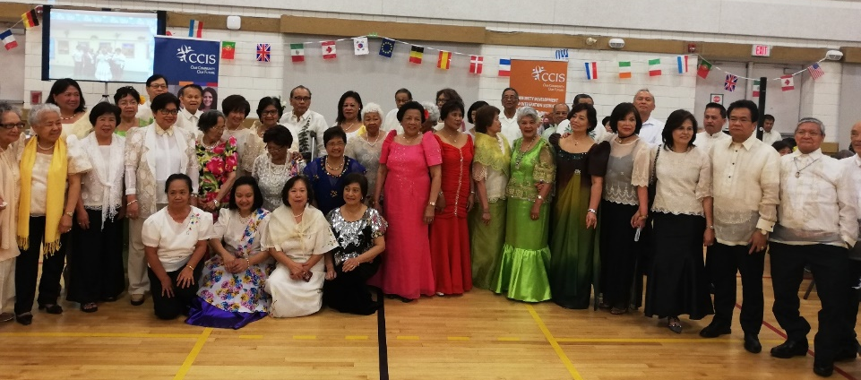
Consul General Asuque spoke at the Multicultural Fiesta held at the Marlborough Park Community Centre and organized by the Calgary Catholic Immigration Society (CCIS), a non-profit organization which provides settlement and integration services to all immigrants and refugees in Southern Alberta. Cultural groups from various countries in Asia, Middle East, Latin America and Africa performed during the multicultural event as part of the celebration of Canadian Multiculturalism Day. The Philippines came with the largest participants with the gentlemen in barong Tagalog and the ladies in Filipiniana dress. The other cultural groups came in their national dress or costume.
1The gentlemen in barong Tagalog and the ladies in Filipiniana attire during the Multicultural Fiesta

In his remarks, Consul General Asuque stressed the importance of multiculturalism, diversity and inclusiveness in the society and the significant role of all ethnic groups in building vibrant and prosperous communities in Canada. He congratulated the Philippine participants for sharing the Filipino culture through songs and dances during the multicultural fiesta as he noted that June of each year is celebrated as Philippine Heritage Month in Alberta and all over Canada in recognition of the significant contributions of Filipino-Canadians to the social, economic, cultural and historical richness of the Province.

Multiculturalism Day is observed every June 27 and is part of a week-long celebration of events culminating in Canada Day on July 1. It is intended to encourage individuals to reflect on their shared commitment to democracy, equality and mutual respect.
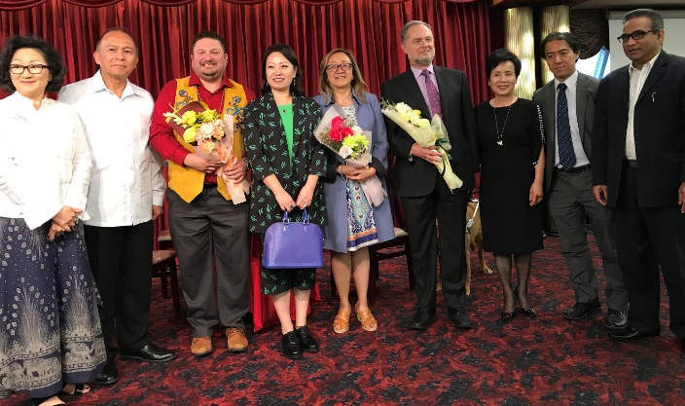
Consul General Asuque later attended the Canadian Multiculturalism Day Forum organized by the Asian Heritage Foundation. The forum is part of the efforts to ensure equitable participation of all Canadians in the continuing evolution and shaping of all aspects of Canadian society and assist in the elimination of any barriers to that participation. The Forum was also attended by the Consul General of China and the Consul of the Japan Consulate General in Calgary. The Philippines, Japan and China are the Asian consular missions among the 9 permanent Consulates General in Alberta.
Consul General Asuque with the guests and speakers at the Canadian Multicultural Day Forum, namely ( L-R) Ms. Teresa Woo-Paw of the Asian Heritage Foundation, Consul General Asuque, Mr. Roy Pogorzelski, Consul General of China Mme. LU Xu, Ms. Patti Pon, Mr. Michael Gottheil, and representatives of the provincial government and the Consulate General of Japan.
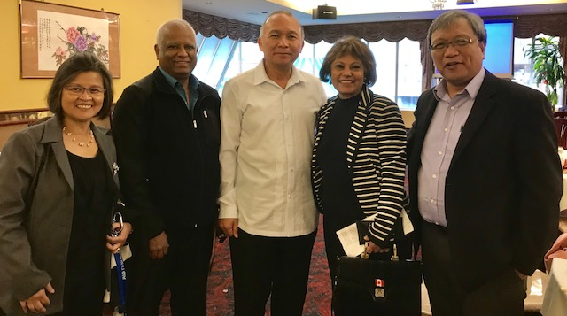
The speakers at the forum were Mr. Michael Gottheil, Chief of Commission and Tribunals of the Alberta Human Rights Commission, Ms. Patti Pon, President and CEO of the Calgary Arts Development and Mr. Roy Pogorzelski, Director of Indigenous Student Affairs and Instructor, University of Lethbridge, Board member of the Canadian Race Relations Foundation and member of the Alberta Anti-Racism Council.
Filipino community leaders Marichu Antonio, Executive Director, Action Dignity, and Mr. Cesar Cala also attended the Forum and dialogue on multiculturalism. END
Ms. Marichu Antonio (L) of Action Dignity and Mr. Cesar Cala ( R) with Rossbina Nathoo (2nd from R), founder of FOCUS on Senior, join Consul General Asuque and guest at the Canadian Multiculturalism Day Forum held in Calgary

