Philippine Consulate General, Calgary
Suite 920, 517 10th Ave SW, Calgary AB, T2R 0A8 ▪ Tel: 403-455-9346; 403-455-9457 ▪
Website: philcongencalgary.org

PR- 49 -2019

PH CONSUL GENERAL VISITS LETHRBIDGE, ALBERTA

23 September 2019, Calgary – Consul General Zaldy Patron visited Lethbridge, Alberta on 13 September 2019 to check on the conditions of the city’s Filipino residents, explore possible cooperation in the areas of education and trade, and promote Philippine tourism.

Lethbridge, with a population of 100,000, is the third largest city in the Province of Alberta, Canada. The Filipinos, numbering about 1,900, is the largest group of immigrants who came to Lethbridge between 2011 and 2016.
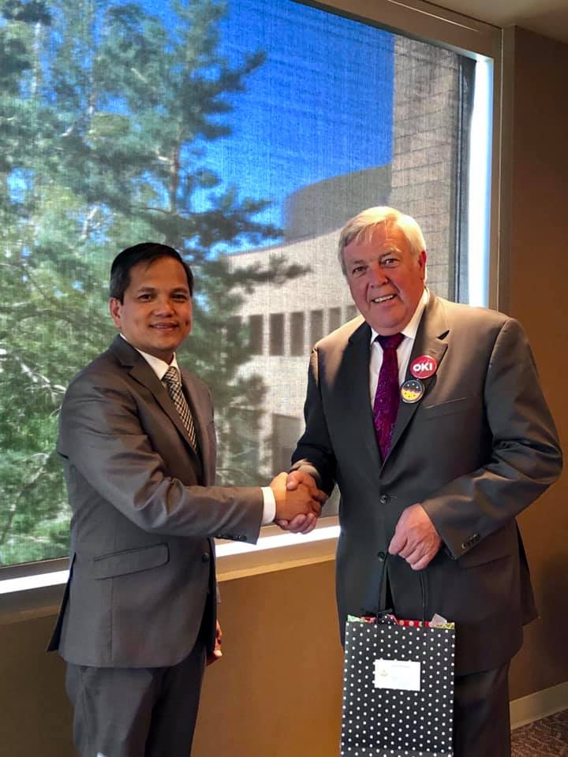
Consul General Zaldy Patron (left) with Lethbridge Mayor Chris Spearman.

During a call on Lethbridge Mayor Chris Spearman, Consul General Patron inquired about the situation of the Filipinos in the city. Mayor Spearman had high praises for the “hard-working, friendly, always smiling” Filipinos. He said that most Filipinos in Lethbridge were professionals, such as teachers, engineers, real estate agents, even priests, and they integrated well into Canadian society. The Consul General thanked the Mayor for the various social services the town provides for the Filipinos.

Consul General Patron and Mayor Spearman also talked about promoting trade between the Philippines and Lethbridge.

Consul General Patron visited the University of Lethbridge (U of L) and met with Dr. Michael Mahon, President and Vice Chancellor, and other university officials. They discussed possible education cooperation between U of L and Philippine education institutions. Consul General Patron was among the university’s guests on 13 September at the inauguration of the U of L’s Science Commons Atrium building, a CAD 280-million building that houses state-of-the-art research equipment and facilities.

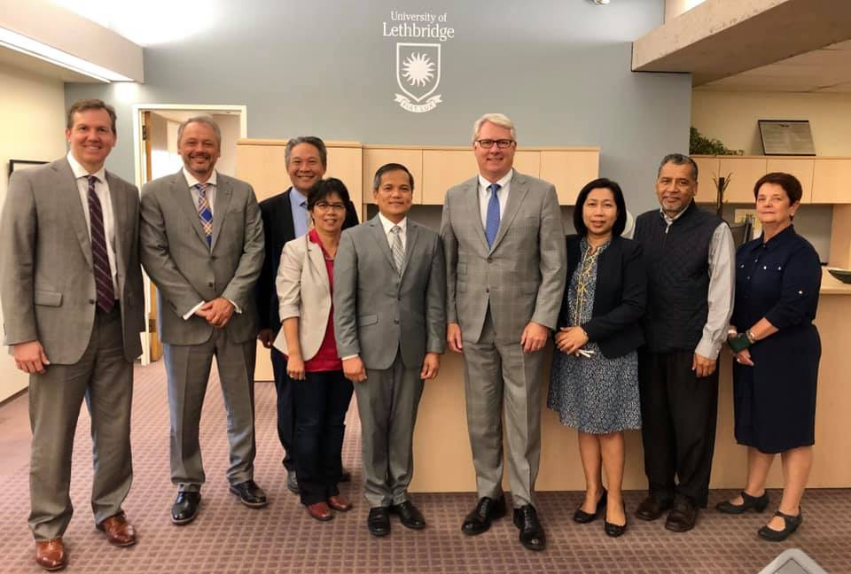
Consul General Zaldy Patron (5th from left), U of L President Dr. Mike Mahon ((4th from right), Consul Pamela Durian-Bailon (3rd from right), Dr. Glenda Bonifacio, Associate Professor, U of L (4th from left), and the other university officials of U of L.

Consul General Patron met with some of the university’s 67 Filipino students and with Dr. Glenda Bonifacio, a Filipino-Canadian Associate Professor at the U of L’s Women and Gender Studies. Dr. Bonifacio authored the book titled “Pinay on the Prairies: Filipino Women and Transnational Identities.”

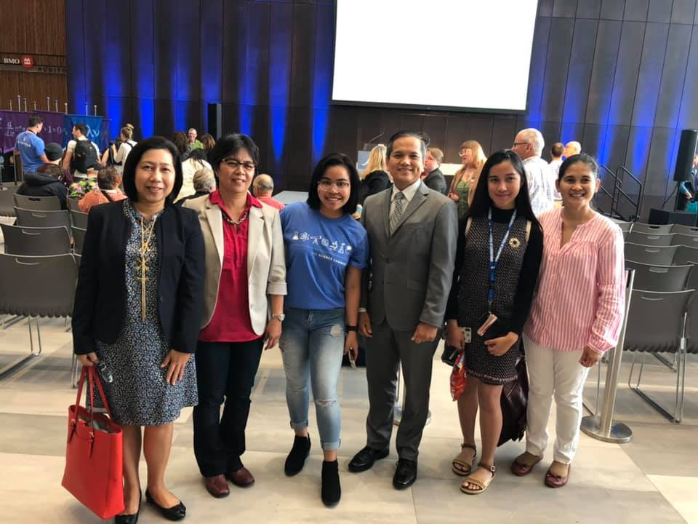
Consul General Zaldy Patron (3rd from right), Consul Pamela Durian-Bailon (extreme left), Dr. Glenda Bonifacio, Associate Professor, U of L (2nd from left) and the Filipino students of U of L.

Lastly, Consul General Patron launched in Lethbridge the Winter Escapade 7, a travel tour taking place in Manila, Bataan, Pampanga and Boracay in the Philippines on 15-22 January 2020. More information about Winter Escapade may be found at www.winterescapadeph.com. END.

