PRESS RELEASE
Philippine Consulate General, Calgary
Suite 920, 517 10th Ave SW, Calgary AB, T2R 0A8 ▪ Tel: 403-455-9346; 403-455-9457 ▪
Website: philcongencalgary.org

PR- 6 -2019

PCG CALGARY CONGRATULATES
PH BOBSLED TEAM FOR PLACING 3RD
AT THE ALBERTA PROVINCIAL CHAMPIONSHIP

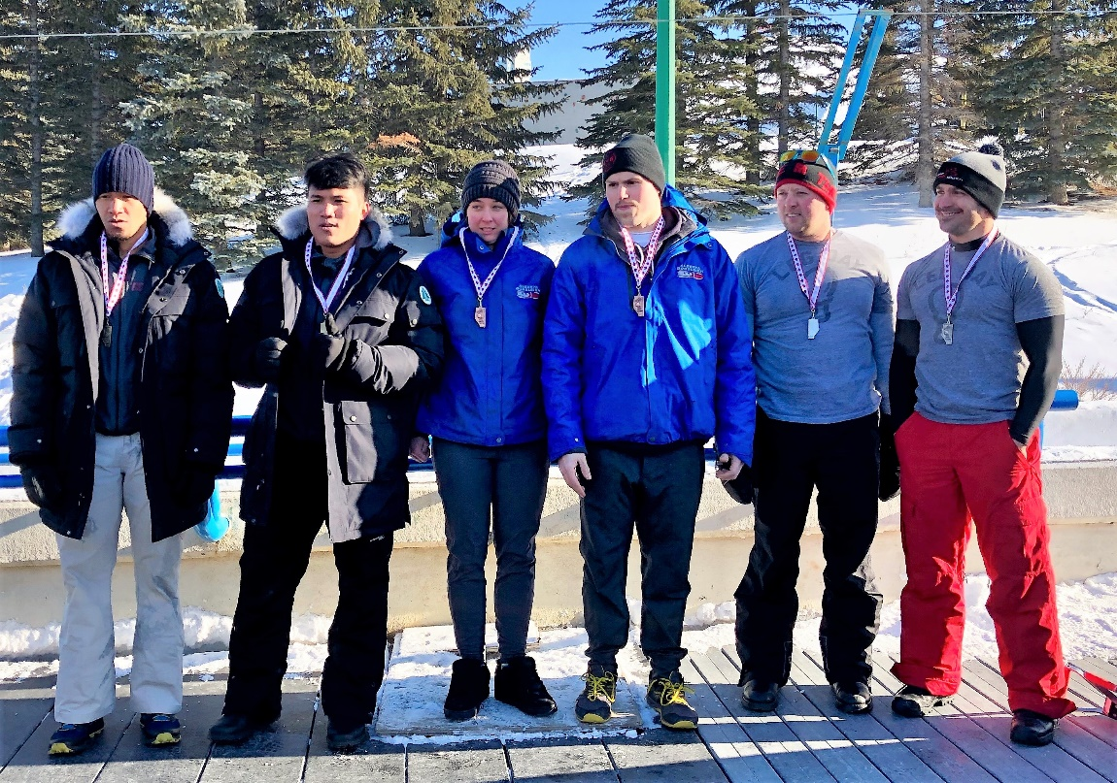
PH Bobsled Team members Rolando Isidro and Jerby Deriada (1st and 2nd from left) won third place in the two-man bobsled competition in the Alberta Provincial Championships held at the Canada Olympic Park in Calgary, Alberta, Canada on 2 March 2019. Standing with them are the 1st and 2nd placers, all from Canada.

5 March 2019, Calgary – The Philippine Consulate General (PCG) in Calgary congratulated the Philippine Bobsled Team that competed in the Alberta Provincial Championship held at the Canada Olympic Park (COP) in Calgary on 2 March 2019. The Alberta Bobsleigh Association organized the competition.

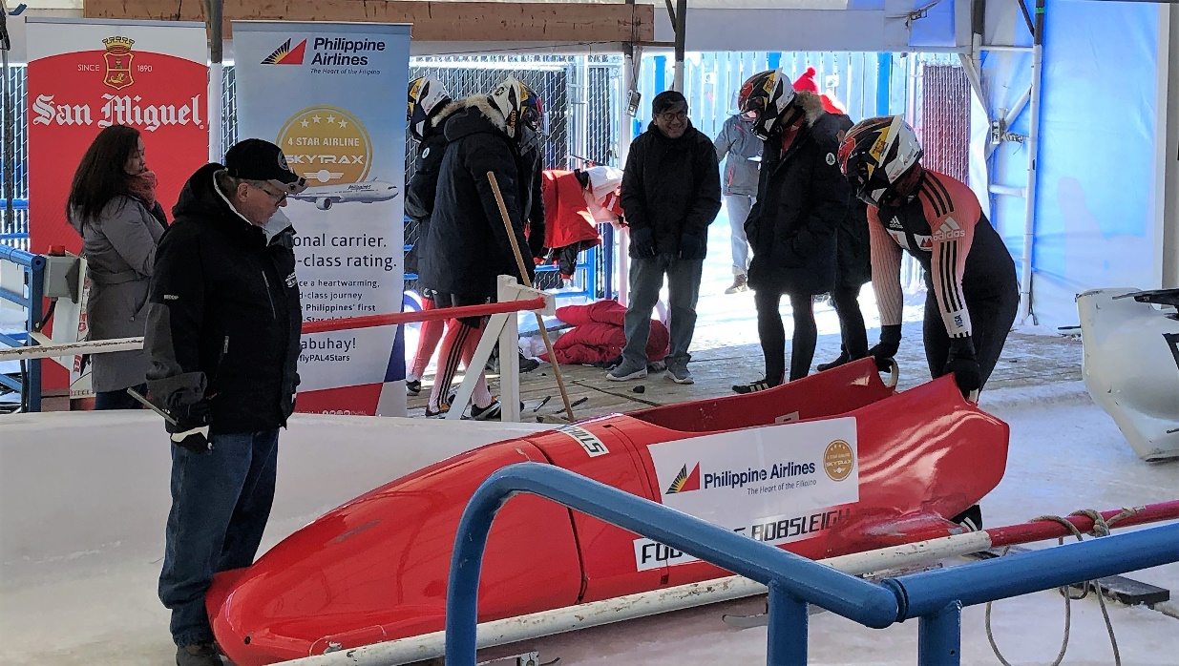
A member of the PH Bobsled Team before the actual run at the Canada Olympic Park.

The Philippine Bobsled Team, composed of Philippine Coast Guard personnel Rolando Isidro, Jerby Deriada, Jeffrey Dela Cruz and Joseph Acosta, joined the two-man bobsled competition with the pair of Messrs. Isidro and Deriada landing in the medal board just after almost one month intensive training in the WinSport Institute, which owns and operates the winter sports training center in the Canada Olympic Park in Calgary.

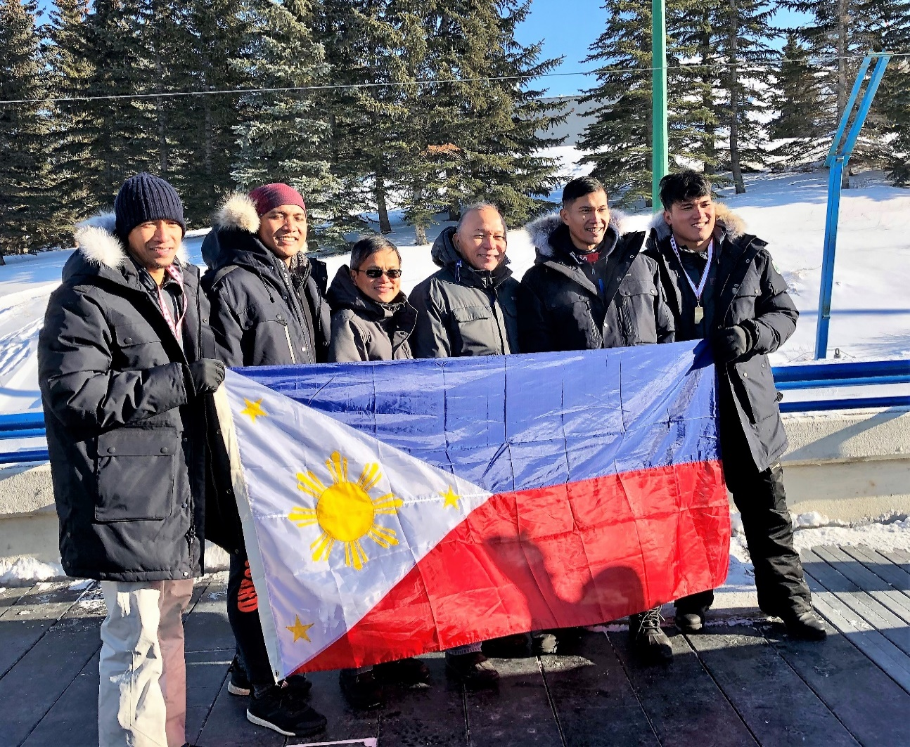
The PH Bobsled Team with Consul General Gilberto Asuque (3rd from right) and Deputy Consul General Zaldy Patron (4th from right).

The team’s participation in the event was part of its preparation to qualify for the 2022 Winter Olympics to be held in Beijing, China.

Consul General Gilberto Asuque also congratulated Mr. Thelmo “Buddy” Cunanan, Jr., President and CEO, Philippine National Bobsled Luge and Skeleton Association (PNBLSA), for bringing the team to Calgary for training and competition. Mr. Cunanan reached out to the Philippine Consulate General in Calgary and the members of the Filipino community in Calgary to support the Philippine Bobsled Team.
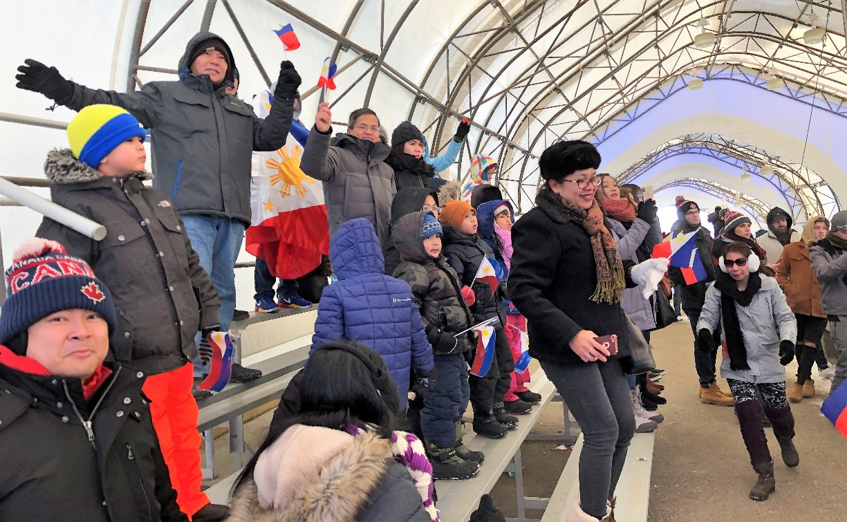
The PCG staff and the members of the Filipino community cheering for the PH Bobsled Team.

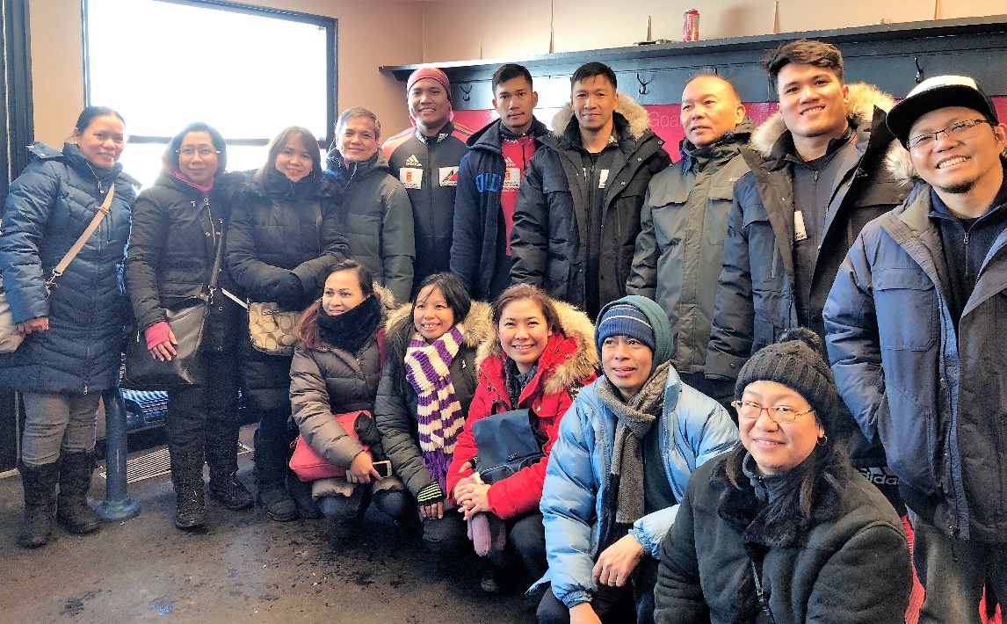
The PH Bobsled Team with the PCG staff.

Consul General Asuque led the officers and staff with family members of the Philippine Consulate General and the members of the Filipino community in cheering for the Philippine Bobsled Team during the actual competition at the bobsled track of the COP in Calgary on 2 March under an almost minus 30 degrees Celsius weather on that day. END.

